**Spin dependent electronic structure of InAs/GaAs quantum dots**

**LAU WEI CHENG**

**ENGINEERING SCIENCE PROGRAMME**

**NATIONAL UNIVERSITY OF SINGAPORE**

**2015/2016**

**Spin dependent electronic structure of InAs/GaAs quantum dots**

**LAU WEI CHENG**

**A THESIS SUBMITTED FOR THE DEGREE OF BACHELOR OF ENGINEERING**

**ENGINEERING SCIENCE PROGRAMME**

**NATIONAL UNIVERSITY OF SINGAPORE**

**Declaration**

I hereby declare that this thesis is my original work and it has been written by me in its entirety. I have duly acknowledged all the sources of information which have been used in this thesis.

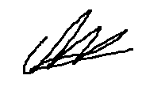

**_____________**

Lau Wei Cheng

April 2016

**Acknowledgement**

I would like to thank my supervisor Professor Yang Hyun Soo for offering me the opportunity to challenge myself and undertake this project. While the progress of the project is not what he has expected, I have benefited and gained much knowledge on a research field that I was not previously familiar with.

My mentor Mehrdad Elyasi for helping me with the formulation of the simulation algorithm for the project, as well as providing much needed advice.

Mr Stefan Birner, CEO of nextnano who provided me with a temporary monthly license to use his commercial software.

I would also like to thank the staff and associates of the ESP office for being always helpful, all the professors who have taught me during my undergraduate course, as well as my course mates for the past 4 years.

**Abstract**

Quantum dots are semiconductor devices that composes of a hundred to a thousand atoms. They have useful properties such as tuning of energy band gap by size. These led to wide applications in medical imaging, LEDs and in solar cells.

A pseudomorphic quantum dot is one that is grown on a substrate that it is lattice mismatched to, which results in an equilibrium strain field in and around the dot. These strained quantum dots were demonstrated to improve laser performance []. Specifically, for the Stranski-Krastanov growth mode, the strain field directly results in the self-assembly of such quantum dots. This project investigates such a pseudomorphic system consisting of an InAs dot on GaAs substrate.

The project focuses on the detailed formulation and modelling of the strain field, piezoelectric potential and finally the band structure around InAs/GaAs self-assembled stacked quantum dots of a truncated pyramidal shape. While the modelling procedure has been widely applied to obtain the strain field, there were little documentation of the algorithm and method. The Finite Difference method was used and the strain field in and around the quantum dot and wetting layer is obtained by minimizing the energy under the Continuum Elasticity Theory using multi-variable Newton-Raphson method. The resulting piezoelectric potential is then calculated in a similar way.

Contents Page

2 Introduction 1

2.1 Quantum Dot 1

2.2 Stranski-Krastanov growth 1

2.3 Stacked quantum dots 3

2.4 Thesis outline 3

3 Formulation for Strain field 5

3.1 Continuum Elasticity Theory 5

3.2 Finite Difference Method 5

3.3 Generalized Newton Raphson Method 6

3.4 Material Parameters 7

4 Results of strain calculation 8

4.1 Performance benchmarks 8

4.2 Algorithm 1 10

4.3 Algorithm 2 11

4.4 Initial Displacement 14

4.4.1 General adjustments 14

4.4.2 Displacement from Wetting Layer 16

4.4.3 Effect of in plane strain 18

4.4.4 Effect of strain in z 19

4.4.5 Effect of factor 20

5 Piezoelectric charge and Potential 22

5.1 Formulation 22

5.2 Results 23

5.2.1 Shear strain 24

5.2.2 Surface plots 25

5.3 Conclusion 27

6 Stacked Quantum Dots 28

6.1 Simulation domain 28

6.2 Distance 2nm 29

6.3 Distance 4nm 31

6.4 Distance 10nm 33

6.5 Conclusion 33

7 Electronic Structure 34

7.1 nextnano 34

7.2 Single Quantum dot 35

7.3 Stacked Quantum dot 37

8 Conclusion 41

List of figures

Figure 1.1 Three different growth modes: (a) Layer or Franck-van der Merwe growth mode; (b) Island or Vollmer-Weber growth mode; (c) Layer plus island or Stranski-Krastanov growth mode 2

Figure 1.2 Schematic drawing of the strain induced self-assembly process. 2

Figure 1.3 TEM image showing the self-assembly of 14 Quantum dot stacks 3

Figure 3.1 Schematic drawing of the dot geometry. Capping layer of GaAs is not shown. The line A shows the linescan in the z direction as discussed below 8

Figure 3.2 Left: The solid line denotes εzz, the dashed line εxx, and the dotted-dashed line εyy along line A. Right: Biaxial (B) and Hydrostatic (I) strain along line A. z=0 starts at the base of the wetting layer 8

Figure 3.3 Parameters of simulation domain for single pyramidal quantum dot 9

Figure 3.4 Flowchart of algorithm 10

Figure 3.5 Hydrostatic strain, I (right), and biaxial strain, B (left) in the pyramidal dot along line A. 11

Figure 3.6 Flowchart of algorithm 2 13  
Figure 3.7 Left: Hydrostatic strain, I, in the pyramidal dot along line A. Right: ε_yy in the pyramidal dot along line A. 13

Figure 3.8 Convergence of the free Energy of the whole system over 300 iterations 14

Figure 3.9 Flowchart of Algorithm 3 15  
Figure 3.10 Left: Hydrostatic strain, I, in the pyramidal dot along line A. Right: εzz in the pyramidal dot along line A. 16

Figure 3.11 Convergence of energy 16

Figure 3.12 Schematic drawing of the initial displacement in the wetting layer and pyramid 17  
Figure 3.13 Normal strains for number of steps, n=300 (left) and n=1000 (right) 18

Figure 3.14 Isotropic and biaxial strains for number of steps, n=300 (left) and n=1000 (right) 18

Figure 3.15 Strain for initial displacement reversed in the x-y plane for upper half of pyramid. n=300 (left) and n=1000 (right). 19  
Figure 3.16 Isotropic and biaxial strain for initial displacement reversed in the x-y plane for upper half of pyramid. n=300 (left) and n=1000 (right). 19

Figure 3.17 Simulation domain after changes in initial displacement to the top half of the pyramid 20

Figure 3.18 Strain after removing displacement in z for top half of pyramid 20  
Figure 3.19 Part of the code showing the use of a ‘factor’ 21

Figure 3.20 Plot of normal strain for factor, f=1 (left) and f=0.5 (right) 21

Figure 3.21 Plot of normal strain for factor, f=0.25 (left) and f=0.1 (right) 21

Figure 4.1 Shear strain along line scan A for f=0.1 (left) and f=0.01 (right) 25

Figure 4.2 Visualization of change in shape due to induced shear strain 25

Figure 4.3 Surface plot (X-Y plane) of potential at Z=base of pyramid (left) and Z=middle of pyramid (right) 26

Figure 4.4 Surface plot (X-Y plane) of potential at Z=top of pyramid 26

Figure 4.5 Surface plot (X-Y plane) near wetting layer 27

Figure 4.6 Surface plot 1 (Y-Z plane) of potential through the middle of the pyramid 27  
Figure 4.7 Surface plot 2 (Y-Z plane) of potential through the middle of the pyramid 28

Figure 5.1 Simulation domain for stacked quantum dots 29

Figure 5.2 Strain profile for stacked dots, d=2 (right) compared with a single dot (left) 30

Figure 5.3 Isotropic and biaxial strain for stacked dots, d=2 (right) compared with a single dot (left) 30

Figure 5.4 X-Y Surface plot of potential at Z=base of lower pyramid (left) and Z=base of upper pyramid (right) 31

Figure 5.5 X-Y Surface plot of potential at Z=top of lower pyramid (left) and Z=top of upper pyramid (right) 31

Figure 5.6 Y-Z Surface plot of potential at through the middle of the pyramid 32  
Figure 5.7 Strain profile for stacked dots, d=4, n=100 (left) compared with n=150 (right) 32

Figure 5.8 Isotropic and biaxial strain for stacked dots, d=4, n=100 (left) compared with n=150 (right) 33

Figure 5.9 X-Y Surface plot of potential at Z=base of lower pyramid (left) and Z=base of upper pyramid (right), d=4nm 33  
Figure 5.10 X-Y Surface plot of potential at Z=top of lower pyramid (left) and Z=top of upper pyramid (right), d=4nm 33

Figure 5.11 Isotropic and biaxial strains (left) and normal strains (right) in a quantum dot molecule with d=10nm 34

Figure 6.1 Command window of nextnano 35

Figure 6.2 Examples of output from nextnano 36

Figure 6.3 Normal strain in single dot along line A. 36

Figure 6.4 Charge density at bas of pyramid 36

Figure 6.5 Charge density at base of pyramid (left) and at half height (right) 37

Figure 6.6 Bandedges along line A 37  
Figure 6.7 Probability density of electron ground state 38

Figure 6.8 Simulation domain with gridlines. d=2nm 38

Figure 6.9 Strain profile along line A 39  
Figure 6.10 Strain profile in the x direction along base of pyramid 39

Figure 6.11 Band edges along line A 39

Figure 6.12 Electron probability density surface plot 40  
Figure 6.13 Electron probability density along line A 41

Figure 6.14 Hole probability density surface plot 41

Figure 6.15 Hole probability density along line A 41

List of tables

Table 2.1 Material parameters used in simulation 7

Table 4.1 Piezoelectric properties of materials 22

# Introduction

## Quantum Dot

Quantum dots (QDs) are semiconductor devices that are also known as artificial atoms, due to their following properties [1]

1) Carriers confinement in 3D

2) Discrete energy levels

3) Delta like energy of states

These properties led quantum dots to be widely studied and are best publicly known to produce the new generation of television. As quantum dots are tuneable to produce different wavelengths of light simple by adjusting its physical size, they can be grown in specific size to produce accurate and small display units, forming the basis of quantum dot screens. The sharp energy of state also result in them having outstanding transport and optical properties, and are useful for diode lasers [3, 4] and biological sensors. Quantum dots are also researched as qubits for quantum information processing due to their ability to be coherently manipulated using ultrafast laser pulses [7]. However, for an isolated dot this is limited to one or two qubit and a pair of stacked quantum dots has potential for building more complex quantum processors [8].

## Stranski-Krastanov growth

There are various techniques available for fabricating QDs, such as by lithography, molecular beam epitaxy (MBE), or metalorganic chemical vapour deposition [14] (MOCVD). In particular, in the growth of pseudomorphic QDs, where there is a lattice mismatch between the dot and its substrate, spontaneous self-assembly takes place.

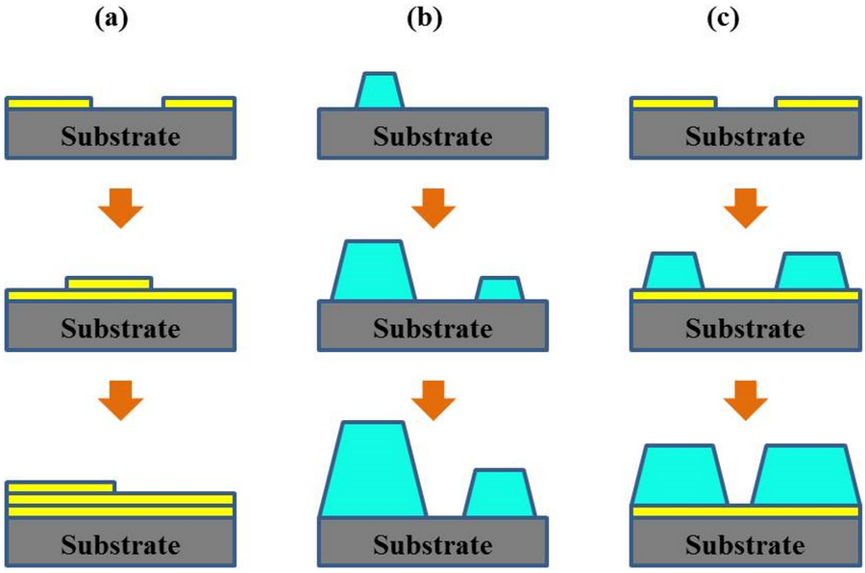

Figure .1[13]: Three different growth modes: (a) Layer or Franck-van der Merwe growth mode; (b) Island or Vollmer-Weber growth mode; (c) Layer plus island or Stranski-Krastanov growth mode

Pseudomorphic quantum dots are formed epitaxially via the Stranski-Krastanov growth mode. Initially, materials are deposited layer-by-layer on the substrate, forming a wetting layer. At a critical thickness a few monolayers thick, nucleation takes place due to the generated strain in the wetting layer and islands are formed as the growing layers relax into their original lattice constant [14]. For comparison, the Stranski-Krastanov and other 2 possible epitaxial growth modes are shown in Figure 1.1.

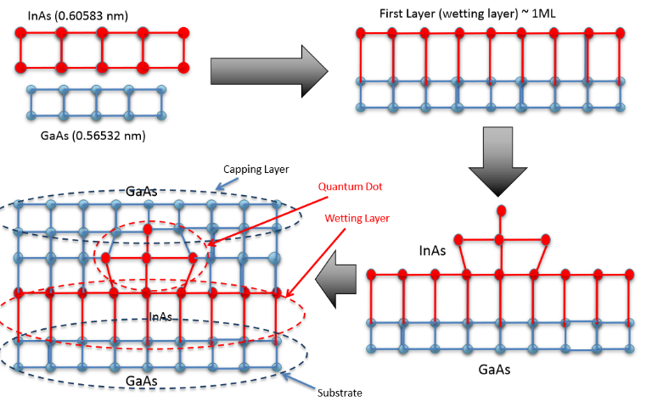

Figure 1.2[1]. Schematic drawing of the strain induced self-assembly process.

Figure 1.2 shows one of the strain induced self-assembly process of the GaAs/InAs quantum dot which we will attempt to simulate in this project. Having a larger lattice constants, the InAs wetting layer deposited on the GaAs substrate has an induced compressive strain. Subsequent InAs deposited then selectively grow in a pyramidal or dome shape, which forms the quantum dot. A capping layer of GaAs is then deposited.

## Stacked quantum dots

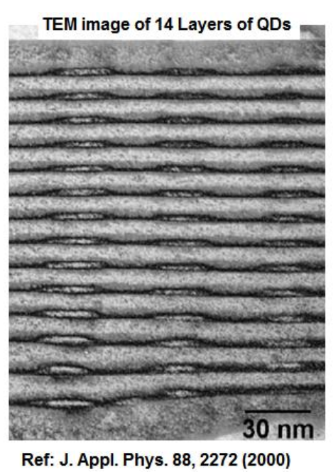

Figure 1.3[1]. TEM image showing the self-assembly of 14 Quantum dot stacks

Due to the lattice mismatch between the materials of the substrate and the quantum dot, strain is induced in the quantum dot which accounts for many of its properties. This strain also induces the self-assembly of quantum dot stacks, where dots selectively grow on sites on top of grown quantum dots. It is known that effect of strain is long range [1] and affects the growth process as well as the electronic structure of neighboring quantum dots.

Fig. 1.3 shows a TEM image of such self-assembly. Such multilayer stacks are useful in application in optoelectronic and photonic devices such as solar cells as it increases the number of photons absorbed or emitted per unit area.

## Thesis outline

As we can see, the strain is important and useful for understanding the electronic structure and properties in and around a quantum dot molecule. While many journals have documented the numerical computation of this strain field [5, 6], there is little information about the formulation and method used. Therefore the focus of the project is to develop a code in MATLAB that allows us to understand the formation of such quantum dots.

Chapter 2 documents the derivation of an algorithm using various theories to calculate the strain field, and outlines the simulation parameters using MATLAB.

Chapter 3 discusses the various improvements made to the code and analyses each of the results of the strain simulation.

Chapter 4 outlines the formulation of the strain induced piezoelectric potential, its implementation in MATLAB and discusses the results.

Finally, Chapter 5 extends the results to the calculation of the band structure using the k.p perturbation theory solved using the Block-Davidson method. The program nextnano is used to investigate the electronic structure.

# Formulation for Strain field

We attempt to calculate the strain field by developing an algorithm based on the Finite Difference method in MATLAB. This chapter outlines the various theories involved in the formulation.

## Continuum Elasticity Theory

The energy of the quantum dot structure can be modelled by the Continuum Elasticity Theory, or the Atomic Valence Force Field Model (VFF). For this project, the Continuum Elasticity Theory which makes use of the displacement vectors is used, as opposed to the VFF which makes use of the atomic position [9]. The use of this theory to compute the strain is widely quoted [5] and was also used by Grundmann et al. (1995) which we can base our benchmarks and comparisons on. Under the theory, the general form of the free energy of a deformed crystal [10] is given by

(2.1)

(2.2)

$$E=\frac{1}{2}C_{ijkl}ε_{ij}ε_{kl}$$

$$ε_{ij}=\frac{1}{2}(\frac{du_{i}}{dx_{j}}+\frac{du_{j}}{dx_{i}})$$

Where $C_{ijkl}$ is the elastic modulus tensor which relates the stress to the strain of the crystal, while $ε_{ij}$ is the strain as given in Eqn (2.2). The index i, j, k and l ranges from 1 to 3. Considering the symmetry and the cubic system, the elastic modulus tensor can be reduced to only 3 components [9], hence the overall energy of the dots is given by

(2.3)

$$E=\frac{1}{2}C_{11}\left(ε_{xx}^{2}+ε_{yy}^{2}+ε_{zz}^{2}\right)+C_{12}\left(ε_{xx}ε_{yy}+ε_{yy}ε_{zz}+ε_{xx}ε_{zz}\right)$$

$$+2C_{44}(ε_{xy}^{2}+ε_{yz}^{2}+ε_{xz}^{2})$$

## Finite Difference Method

The finite difference method is a numerical approximation commonly used to solve differential equations. It involves a linear polynomial approximation defined by the Taylor series and the first order approximation using the central difference method [15] is given by

(2.4)

$$f^{'}\left(x\right)=\frac{1}{2h}\left[f\left(x+h\right)-f(x-h)\right]+O(h^{2})$$

Where h is the step size while the big O notation represents that the error is in the order of h2. The quantum dots together with the wetting layer is represented with a mesh and h is given by the step size in each of the 3 spatial directions. For this problem, this is applied in Eqn (2.2) to approximate the strain from neighboring displacement values, one of the components is shown in Eqn (2.5). It is observed that the error can be minimized by using a sufficiently small step size.

(2.5)

$$ε_{xx}=\frac{u_{x}\left(x+∆x,y,z\right)-u_{x}(x-∆x,y,z)}{2∆x}$$

## Generalized Newton Raphson Method

The Newton Raphson method is a well-known algorithm used to solve for the roots of a function. For a one dimensional function f(x), an iterative process can be used to bring the initial guess, x0, closer to the root of the function where the iteration is defined by

(2.7)

(2.6)

$$∆x=-\frac{{f(x}_{0})}{f^{'}(x_{0})}$$

$$x_{n+1}=x_{n}+∆x$$

By taking the first differential of Eqn (2.6), the algorithm can be used to optimize the function, finding its minimum instead of the root. Furthermore, since the energy function as defined by Eqn (2.3) contains more than 1 variable (6 strains components) in the problem, the multi-variable version of Newton Raphson method is required, where each element is a vector or matrix as given by

(2.8)

6 by 1

6 by 6

6 by 1

$$∆ε=-H^{-1}\left(E\right)grad(E)$$

In this version, the gradient of the function is required, which contains the first differentials with respect to all 6 strain components, as well as the hessian which contains all the second differentials. They can be derived from Eqn (2.3) to give

$$grad\left(E\right)=\left(\begin{matrix}\frac{∂E}{∂ε_{xx}} \\ \frac{∂E}{∂ε_{yy}} \\ \begin{matrix}\frac{∂E}{∂ε_{zz}} \\ \frac{∂E}{∂ε_{xy}} \\ \begin{matrix}\frac{∂E}{∂ε_{yz}} \\ \frac{∂E}{∂ε_{xz}}\end{matrix}\end{matrix}\end{matrix}\right)=\left(\begin{matrix}C11\left(ε_{xx}\right)+C12\left(ε_{yy}+ε_{zz}\right) \\ C11\left(ε_{yy}\right)+C12(ε_{xx}+ε_{zz}) \\ \begin{matrix}C11\left(ε_{zz}\right)+C12(ε_{xx}+ε_{yy}) \\ 4C44\left(ε_{xy}\right) \\ \begin{matrix}4C44\left(ε_{yz}\right) \\ 4C44\left(ε_{xz}\right)\end{matrix}\end{matrix}\end{matrix}\right)$$

$$H\left(E\right)=\left(\begin{aligned}C11 \\ C12 \\ C12 \\ 0 \\ 0 \\ 0\end{aligned} \begin{aligned}C12 \\ C11 \\ C12 \\ 0 \\ 0 \\ 0\end{aligned} \begin{aligned}C12 \\ C12 \\ C11 \\ 0 \\ 0 \\ 0\end{aligned}\begin{aligned}0 \\ 0 \\ 0 \\ C44 \\ 0 \\ 0\end{aligned}\begin{aligned}0 \\ 0 \\ 0 \\ 0 \\ C44 \\ 0\end{aligned}\begin{aligned}0 \\ 0 \\ 0 \\ 0 \\ 0 \\ C44\end{aligned}\right)$$

In the formation of the quantum dots, the strain is propagated such that the overall potential energy of the system is minimized. Therefore, by computing each strain component using the finite difference method we can use this iterative process to update the strain and displacements in and around the quantum dots such that the elastic energy E converges to a minimum.

(2.10)

(2.9)

## Material Parameters

The material parameters required for the simulation are shown in Table 1. In order to test the performance of the code, the simulation is done based on the parameters used by Grundmann et al. (1995) [5]. The simulation space is a cube of length 40nm, which consists of a single pyramidal quantum dot of InAs, with GaAs substrate and capping layer. The wetting layer (WL) has a thickness of 0.5nm and the pyramid has a base length of 12nm.

Table 2.[16]: Material parameters used in simulation

|  |  |  |
| --- | --- | --- |
| Properties | GaAs | InAs |
| Lattice constant, a (A) | 5.65325 | 6.0583 |
| (1010 Pa) | 11.9 | 8.34 |
| (1010 Pa) | 5.34 | 4.54 |
| (1010 Pa) | 5.96 | 3.95 |

# Results of strain calculation

## Performance benchmarks

The performance of the code is assessed by comparing the strains along line scan A of Figure 3.1, as obtained by various sources [5,17].

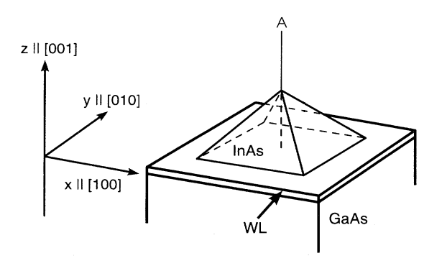

Figure 3.1[5]. Schematic drawing of the dot geometry. Capping layer of GaAs is not shown. The line A shows the linescan in the z direction as discussed below.

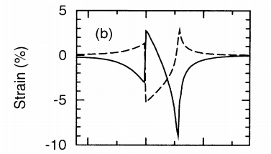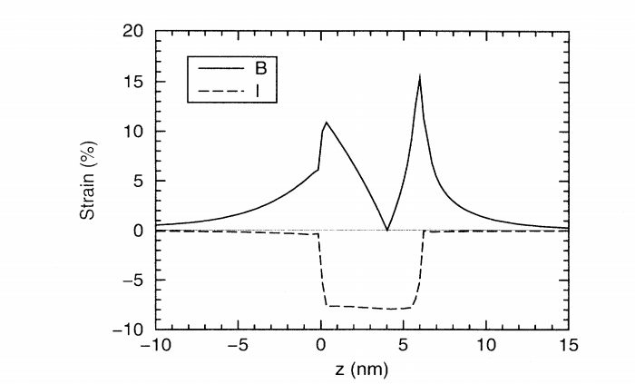

Figure 3.2[5]. Left: The solid line denotes εzz, the dashed line εxx, and the dotted-dashed line εyy along line A. Right: Biaxial (B) and Hydrostatic (I) strain along line A. z=0 starts at the base of the wetting layer

(3.2)

(3.1)

$$I=ε_{xx}{+ε}_{yy}+ε_{zz}$$

$$B^{2}={(ε_{xx}{-ε}_{yy})}^{2}+{(ε_{yy}{-ε}_{zz})}^{2}+{(ε_{zz}{-ε}_{xx})}^{2}$$

Figure 3.1 is a schematic diagram of the simulation domain. As discussion earlier in Chapter 1.2, an InAs wetting layer is grown on a substrate, which then supports the growth of an InAs quantum dot which is in the shape of a full pyramid for the simulation. Figure 3.2 shows the plots reported from published journals of the various strain components along line A in Figure 3.1. Therefore, the results can be assessed based on the following 4 criteria:

1) Computation time

2) Convergence and minimization of Energy function (Eqn 2.3)

3) Plot of individual normal strains, comparison with Figure 3.2

4) Plot of isotropic and biaxial strains, comparison with Figure 3.2

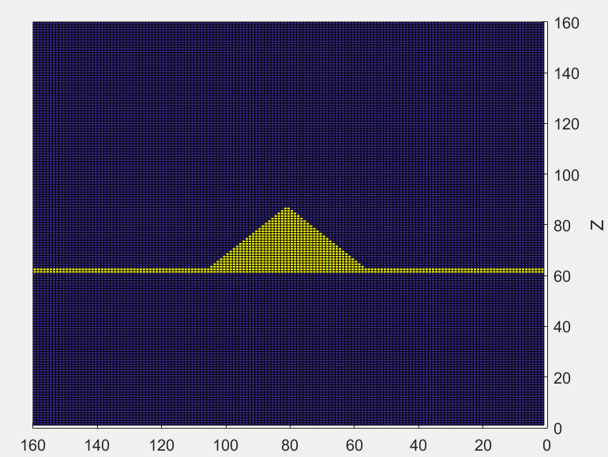

Base = 12nm

Height = 6nm

WL = 0.5nm

Figure 3.3 Parameters of simulation domain for single pyramidal quantum dot

Figure 3.3 shows the Y-Z plane of the simulation domain in the middle of the dot. The substrate and capping layer are made of GaAs and shown in blue while the wetting layer and QD are made of InAs and shown in yellow. The step size used is 0.25nm hence the entire simulation domain is 160 by 160 by 160 voxels.

Being computational based, the focus of the project is on the formulation, algorithm and testing of the codes. There were multiple revisions including drastic changes to the code. The following subchapters cover each of these algorithms and the learning points from each of them.

## Algorithm 1

The first algorithm was based on a 3 by 3 hessian which involves differentials with respect to the 3 components of the displacement field. Forward finite difference was used to approximate the strain and used to calculate the gradient and hessian components.

$$ε_{xx}=\frac{u_{x}\left(x+∆x,y,z\right)-u_{x}(x,y,z)}{∆x}$$

Note that Eqn 3.3 is similar but different from Eqn 2.5. This was substituted into Eqn 2.3, such that the free energy becomes a function of displacement instead of strain. In other words,

(3.3)

(3.4)

$$E=f\left(ε_{xx},ε_{yy},ε_{zz},ε_{xy},ε_{xz},ε_{yz}\right)→f(u_{x},u_{y},u_{z})$$

Then, the gradient and hessian as required in Eqn 2.8 are calculated.

(3.5)

$$grad\left(E\right)=\left(\begin{matrix}\frac{∂E}{∂u_{x}} \\ \frac{∂E}{∂u_{y}} \\ \frac{∂E}{∂u_{z}}\end{matrix}\right), H\left(E\right)=\left(\begin{matrix}\frac{∂E}{∂^{2}u_{x}} & \frac{∂E}{∂u_{x}∂u_{y}} & \frac{∂E}{∂u_{x}∂u_{z}} \\ \frac{∂E}{∂u_{y}∂u_{x}} & \frac{∂E}{∂^{2}u_{y}} & \frac{∂E}{∂u_{y}∂u_{z}} \\ \frac{∂E}{∂u_{z}∂u_{x}} & \frac{∂E}{∂u_{z}∂u_{y}} & \frac{∂E}{∂^{2}u_{z}}\end{matrix}\right)$$

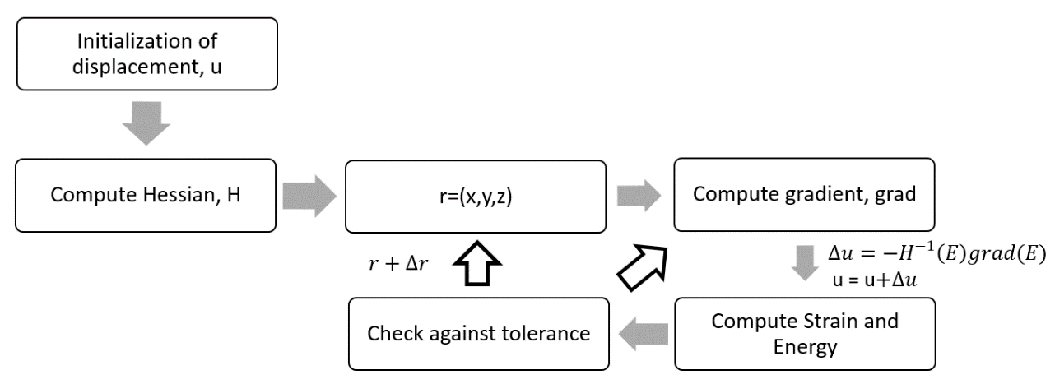

Figure 3.4 Flowchart of algorithm

Figure 3.4 is a flowchart that shows the algorithm. The energy calculated at each point is minimized until a tolerance is reached, before moving to the next point in the simulation space. For this version, the computation domain is a cube of length 50nm with a step size of 0.5nm. The dot is located on grids 51 to 63.

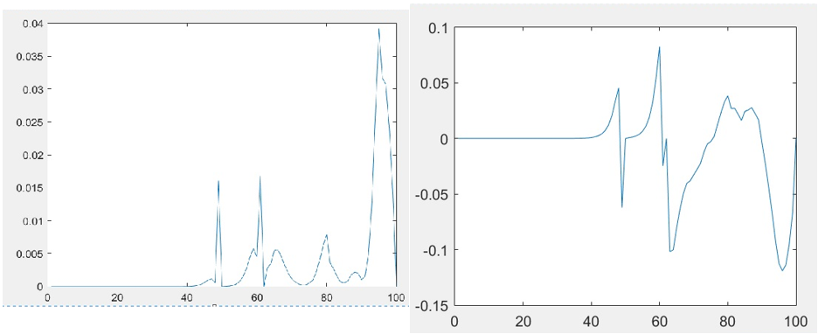 Figure 3.5 Hydrostatic strain, I (right), and biaxial strain, B (left) in the pyramidal dot along line A.

The results obtained are shown in Figure 3.5. As can be seen, the results were very different from Figure 3.2. The isotropic strain was not entirely negative or confined within the dot. The biaxial strain has a minimum but the results were too inaccurate to be of any reliable use. On top of that, the computation time took over 2 hours and was too inefficient to be tested and debugged with.

More than 2 months was spent on the formulation and coding that resulted in these results. While it was incorrect, we could analyze and learn from the errors made.

1. Since forward difference was used, the error is in the order of O(h), which is larger for small step size in comparison with the central difference method.
2. The code worked by minimizing the energy at each point, which is unreliable since the calculated strain at each point depends on each neighboring point. In other words, going through the simulation from top to bottom of the simulation space would yield a different result as the opposite direction would.
3. Finally, the formulation based on displacement poses the problem that central difference cannot be used. This led to a different formulation as will be discussed in the next version of the code.

## Algorithm 2

The inaccuracy of the first algorithm showed that the formulation was likely to be bad for the computation. The new formulation was based upon differentials with respect to the strain components instead of the displacement vector. This allowed the central difference method to be used as the displacement vector is not required for the differentiation. The gradient are first calculated before any approximation is done (Eqns 3.6-3.7). Then, the approximation is used to calculate each of the matrix components (Eqn 3.8).

(3.8)

(3.7)

(3.6)

$$grad\left(E\right)=\left(\begin{matrix}\frac{∂E}{∂ε_{xx}} \\ \frac{∂E}{∂ε_{yy}} \\ \begin{matrix}\frac{∂E}{∂ε_{zz}} \\ \frac{∂E}{∂ε_{xy}} \\ \begin{matrix}\frac{∂E}{∂ε_{yz}} \\ \frac{∂E}{∂ε_{xz}}\end{matrix}\end{matrix}\end{matrix}\right)=\left(\begin{matrix}C11\left(ε_{xx}\right)+C12\left(ε_{yy}+ε_{zz}\right) \\ C11\left(ε_{yy}\right)+C12(ε_{xx}+ε_{zz}) \\ \begin{matrix}C11\left(ε_{zz}\right)+C12(ε_{xx}+ε_{yy}) \\ 4C44\left(ε_{xy}\right) \\ \begin{matrix}4C44\left(ε_{yz}\right) \\ 4C44\left(ε_{xz}\right)\end{matrix}\end{matrix}\end{matrix}\right)$$

$$H\left(E\right)=\left(\begin{aligned}C11 \\ C12 \\ C12 \\ 0 \\ 0 \\ 0\end{aligned} \begin{aligned}C12 \\ C11 \\ C12 \\ 0 \\ 0 \\ 0\end{aligned} \begin{aligned}C12 \\ C12 \\ C11 \\ 0 \\ 0 \\ 0\end{aligned}\begin{aligned}0 \\ 0 \\ 0 \\ C44 \\ 0 \\ 0\end{aligned}\begin{aligned}0 \\ 0 \\ 0 \\ 0 \\ C44 \\ 0\end{aligned}\begin{aligned}0 \\ 0 \\ 0 \\ 0 \\ 0 \\ C44\end{aligned}\right)$$

$$ε_{xx}=\frac{u_{x}\left(x+1,y,z\right)-u_{x}(x-1,y,z)}{2∆x}$$

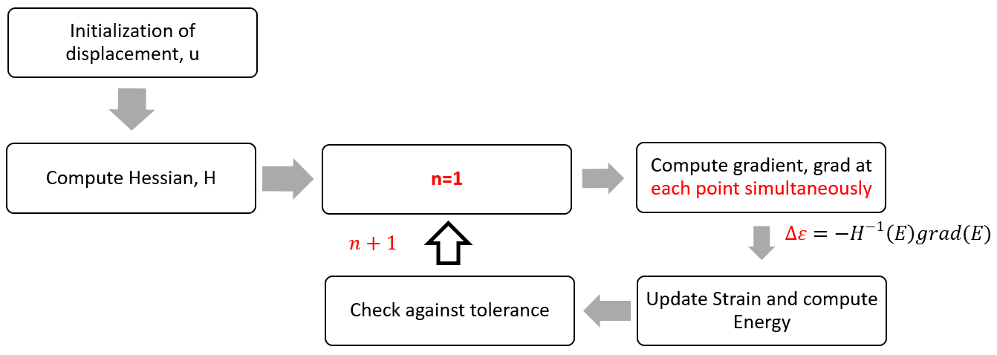

Figure 3.6 Flowchart of algorithm 2

The variables were also redefined completely to improve the computation time. Instead of point by point minimization, the whole array is updated at each step of the code, solving the problem of unreliability as pointed out in Chapter 3.2. The energy of the whole system is then minimized. MATLAB is able to perform computation between multiple 3-Dimensional arrays much faster than applying calculation component wise to obtain the new array. As such, it is favorable to redefine variables in a way to make use of array calculations instead of multiple ‘nested for loops’.

For this, the computation space was reduced to a cube of length 40nm with the same step size of 0.5nm. The dot is located on grids 32 to 43.

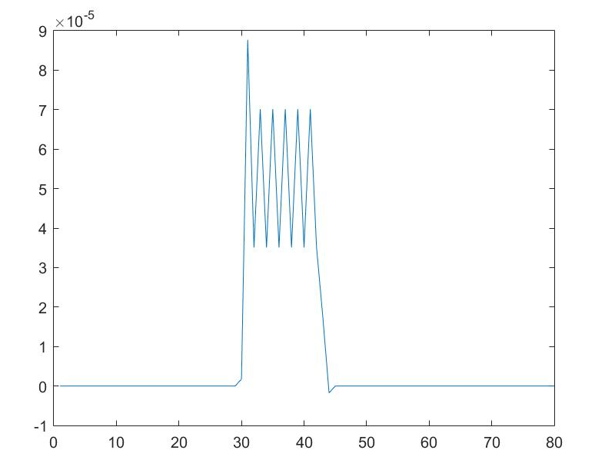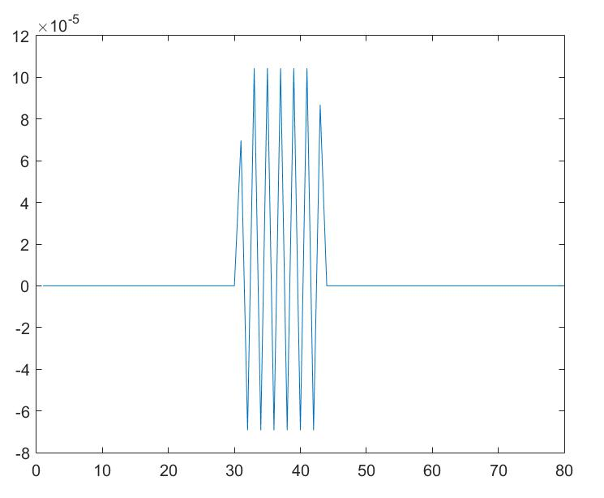

Figure 3.7 Left: Hydrostatic strain, I, in the pyramidal dot along line A. Right: $ε_{yy}$ in the pyramidal dot along line A.

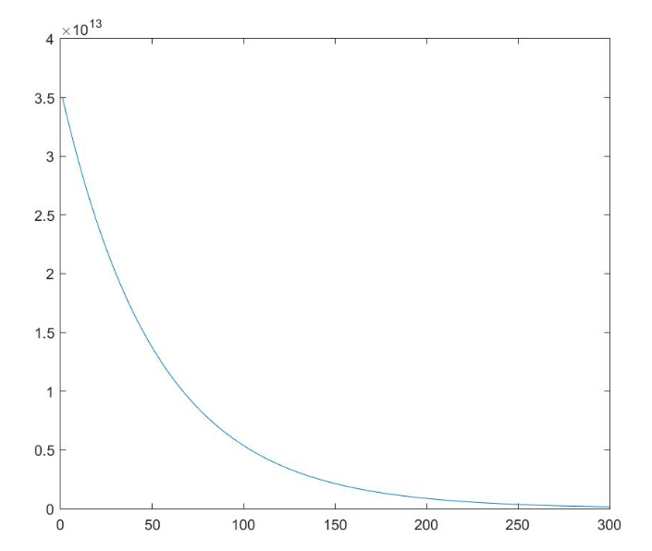

Figure 3.8 Convergence of the free Energy of the whole system over 300 iterations

The free energy was minimized from 3.502830e+13 to 1.128441e+07 over 1000 iterations, and this was completed in only 53s, a great improvement in the computational time. Figure 3.7 shows this convergence over the first 300 steps. Figure 3.6 shows that the isotropic strain is confined within the quantum dot. However, the shape and sign of both I and $ε_{yy}$ is different, again compared to Figure 3.2.

## Initial Displacement

It is well-known that the accuracy and performance of the Newton-Raphson method depends heavily on the initial conditions. For our simulation, the initial conditions comes in the form of initial displacement based on the relative lattice mismatch between the materials. This section discusses the multiple simulations done with varying initial displacement to obtain the best results. Multiple other adjustments were also made along the way and their impact is also discussed.

### General adjustments

The algorithm outlines in Chapter 3.3 computes the change in each of the 6 strain components from each iteration of the Newton-Raphson step and updates the corresponding strain values directly. The displacement values at each of the points were kept as the initial value. As an improvement, the change in strain computed is used to update the displacement values and the new strain components are in turn calculated again from these updated displacement fields. This is confusing as since the strain is the desired output, going backwards to update the displacement and calculating the strain from it again seems counter-intuitive. However, as the displacement in each point contributes to and is updated by more than 1 component of the strain, it is possible that this will improve the accuracy. This is illustrated below in Figure 3.9.

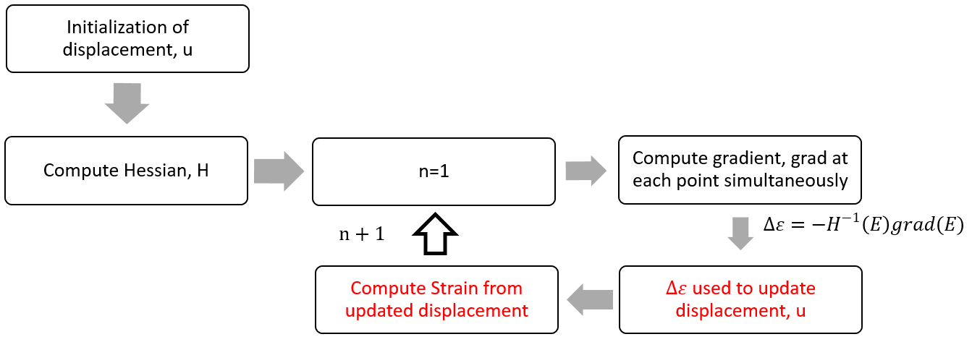

Figure 3.9 Flowchart of Algorithm 3

(3.12)

(3.9)

$$\left(\begin{matrix}\begin{matrix}∆ε_{xx} \\ \begin{matrix}\begin{matrix}∆ε_{yy} \\ ∆ε_{zz}\end{matrix} \\ ∆ε_{yz}\end{matrix}\end{matrix} \\ ∆ε_{xz} \\ ∆ε_{xy}\end{matrix}\right)=\left(\begin{matrix} & ⋯ & \\ ⋮ & H^{-1}(E) & ⋮ \\ & ⋯ & \end{matrix}\right)\left(\begin{matrix} & ⋯ & \\ ⋮ & grad(E) & ⋮ \\ & ⋯ & \end{matrix}\right)$$

$$u_{x}\left(x+1,y,z\right)=u_{x}\left(x+1,y,z\right)+∆ε_{xx}×\frac{1}{2}×2∆x$$

$$u_{x}\left(x-1,y,z\right)=u_{x}\left(x-1,y,z\right)-∆ε_{xx}×\frac{1}{2}×2∆x$$

$$u_{x}\left(x,y+1,z\right)=u_{x}\left(x,y+1,z\right)+∆ε_{xy}×\frac{1}{2}×2∆y$$

$$u_{y}\left(x+1,y,z\right)=u_{y}\left(x+1,y,z\right)+∆ε_{xy}×\frac{1}{2}×2∆x$$

Eqns 3.10-3.11 shows an example of the normal strain updating the displacement field. Eqns 3.12-3.13 shows how the calculated change in shear strain affects the displacement field in both the x and y directions. The result is that the displacement vector at each voxel is dependent on multiple strain components.

(3.10)

(3.11)

(3.12)

(3.13)

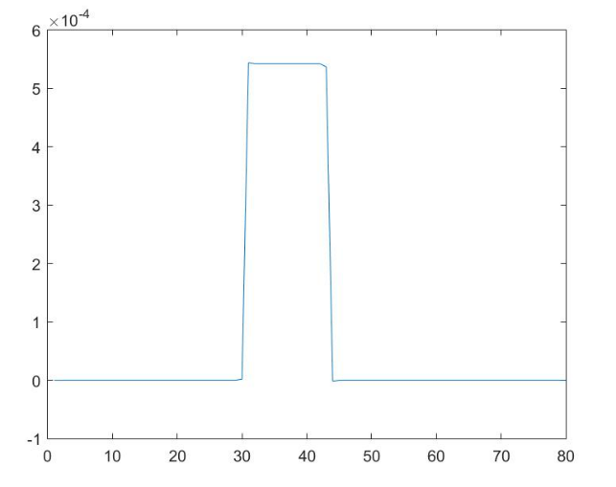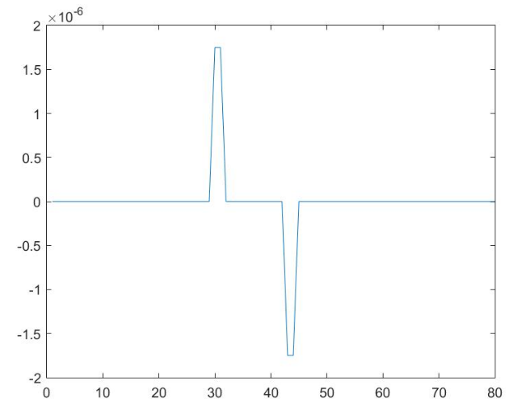

Figure .10 Left: Hydrostatic strain, I, in the pyramidal dot along line A. Right: εzz in the pyramidal dot along line A.

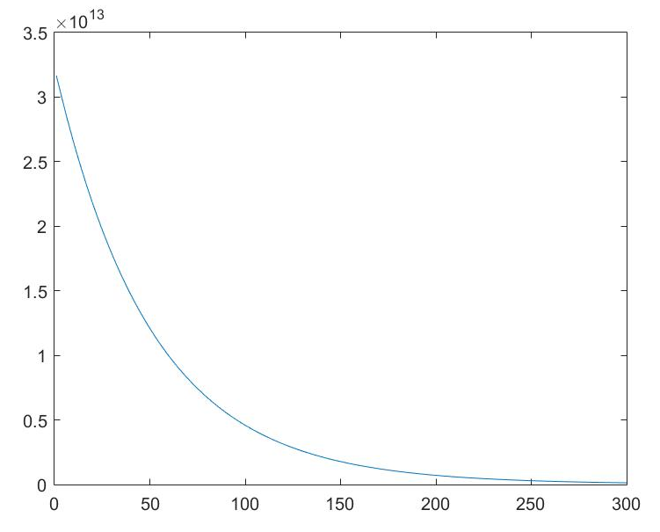

Figure 3.11 Convergence of energy

The free energy was minimized from 3.502830e+13 to 4.944385e+07 over 1000 iterations, and this was completed in 246s. Figure 3.10 shows the effect of this change, where the graph for that of isotropic strain within the dot has flattened out. Also, the step size in all directions was reduced from 0.5 to 0.25 to improve the accuracy, at the expense of computation time. Therefore the simulation domain becomes 160 by 160 by 160 going forward.

### Displacement from Wetting Layer

A good initial displacement have to be carefully chosen through testing. As shown in Figure 1.2, the InAs wetting layer is compressed in the x-y direction while elongated in the z direction due to the poisson effect. Therefore, the first guess is to have similar conditions in the pyramid.

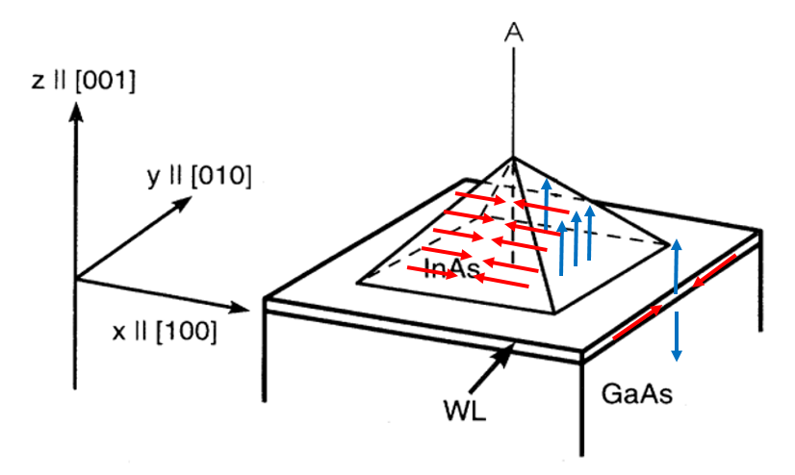

Figure .12 Schematic drawing of the initial displacement in the wetting layer and pyramid

Figure 3.12 is a schematic drawing of the initial displacement. The red arrows shows the displacement in the x-y plane while the blue arrows show the displacement in the z direction. The length of the arrows represent the magnitude and the initial values is given as the lattice mismatch, $∆ε$ between InAs and GaAs. The in plane displacement is compressive towards the middle line A while the displacement in z is outwards from the wetting layer. Note that the initial displacement applies to the whole InAs dot instead of just on the surface. In the code, this is given by

$$u_{i}\left(x,y,z\right)=\left\{\begin{aligned}∆ε if i≤\frac{i_{max}}{2} \\ -∆ε if i>\frac{i_{max}}{2}\end{aligned}\right., i=x,y$$

$$u_{z}\left(x,y,z\right)=\left\{\begin{aligned}-∆ε if i<z=WL \\ ∆ε if i≥z=WL\end{aligned}\right.$$

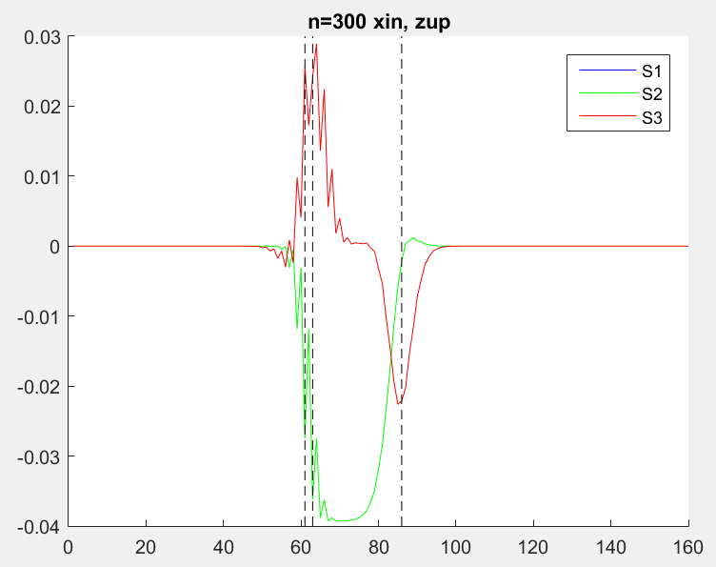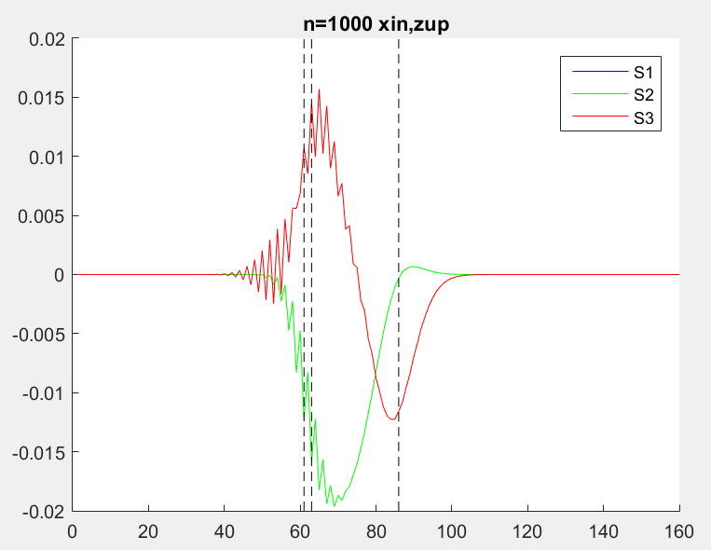

(3.14)

(3.15)

Figure 3.13 Normal strains for number of steps, n=300 (left) and n=1000 (right)



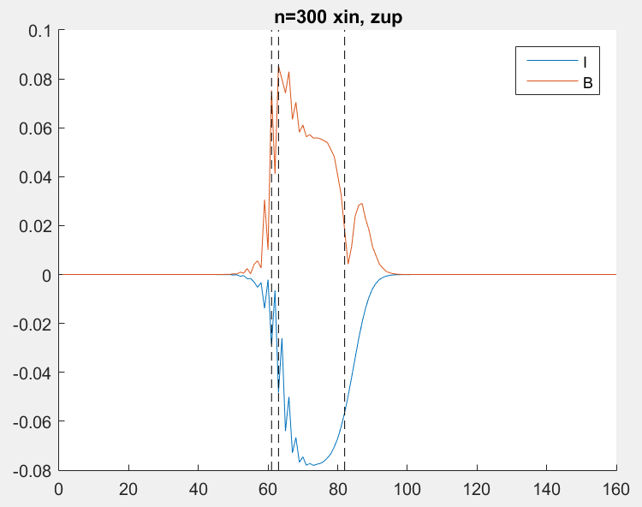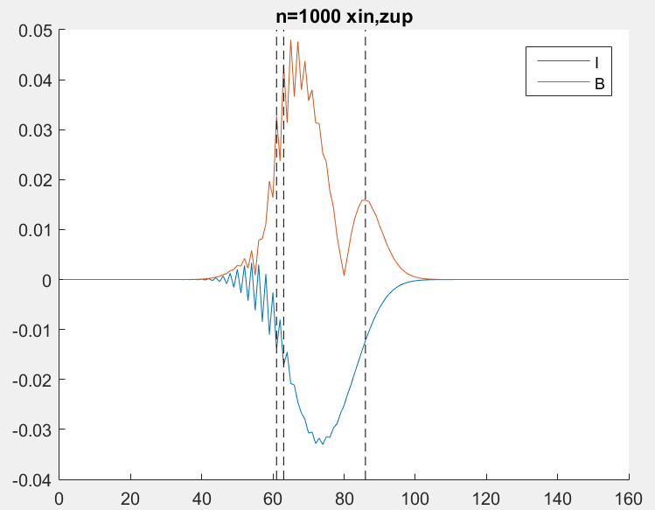

Figure π Isotropic and biaxial strains for number of steps, n=300 (left) and n=1000 (right)

Figure 3.13 shows the output normal strain along line A of Figure 3.12 at 300 steps and at 1000 steps. The first dotted vertical line marks the bottom of the wetting layer, while the next 2 marks the bottom and top of the pyramid respectively. Together with figure 3.14, the results are much better than the previous algorithm. There are still some differences from the ideal results (Figure 3.2, shown again for comparison), such as having smoother curves, and the strain in the upper pyramid.

### Effect of in plane strain

According to the relaxation [14] of the dot with increasingly height and the shape of the pyramid, we can consider possible adjustments to the initial displacement. With height, the influence of the compressive x-y strain by the wetting layer reduces. Also, due to the capping layer of GaAs over the dot, there also exists a compressive strain in the z-direction on the slanted face of the pyramid. Hence, we test the effect of changing the in plane initial displacement for the top half of the pyramid.

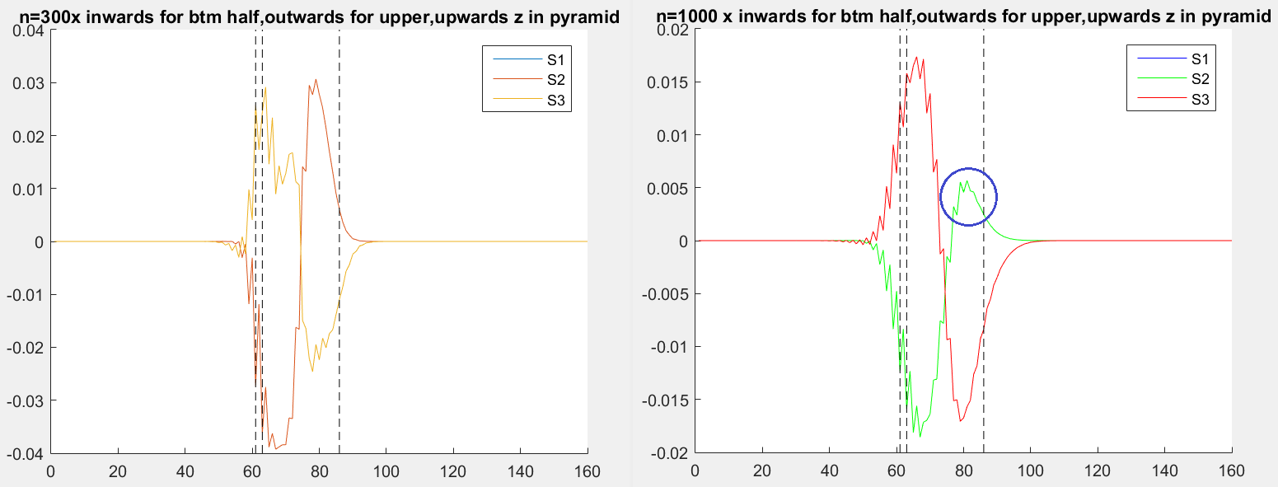

Figure 3.15 Strain for initial displacement reversed in the x-y plane for upper half of pyramid. n=300 (left) and n=1000 (right).

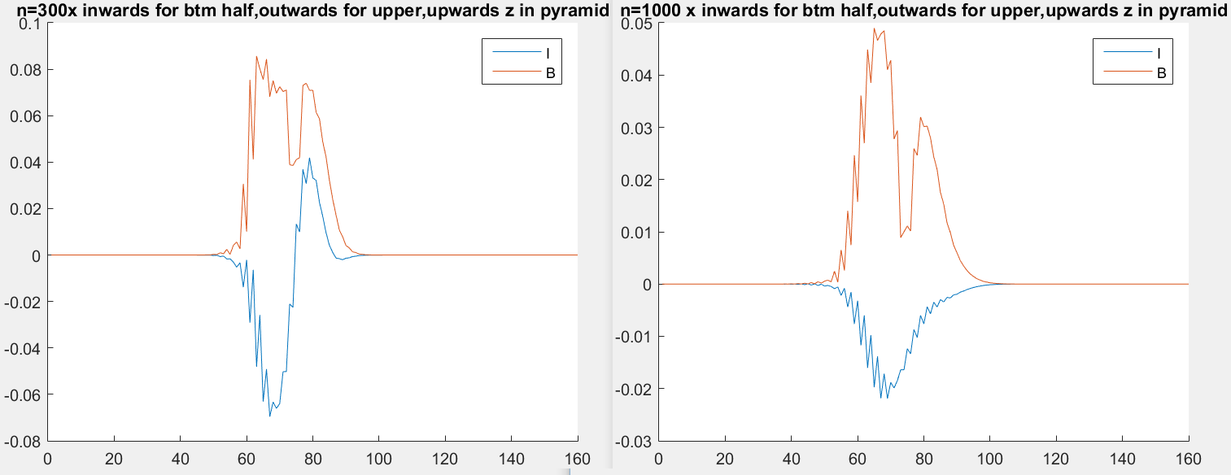

Figure 3.16 Isotropic and biaxial strain for initial displacement reversed in the x-y plane for upper half of pyramid. n=300 (left) and n=1000 (right).

The initial displacement in the upper half of the pyramid is reversed, such that they are outwards from the middle of the dot instead of being compressive. The results are shown in Figure 3.15-3.16. The difference is highlighted by the blue circle where we begin to see a peak near the top of the pyramid. The improvement in accuracy tells us that this was a step in the right direction and this change should be kept.

### Effect of strain in z

Following the logic from the previous sub chapter, we expect that the initial displacement in the z direction for the upper pyramid should be reduced. This initial displacement is set to zero in the upper half of the pyramid. Figure 3.17 summarizes the current simulation domain.

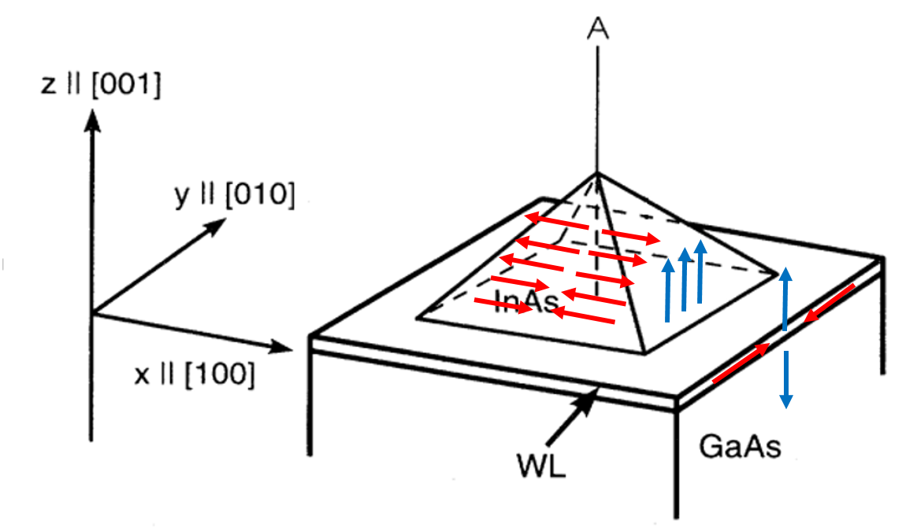

Figure 3.17 Simulation domain after changes in initial displacement to the top half of the pyramid

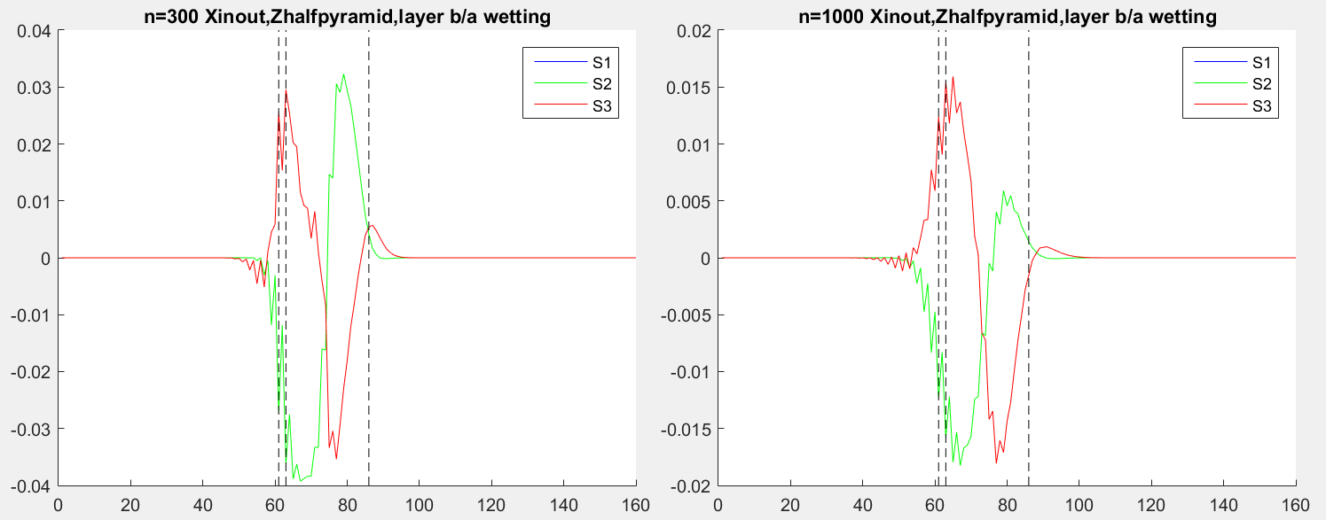

Figure 3.18 Strain after removing displacement in z for top half of pyramid

This change made reduced the accuracy of the simulation. A negative strain in z is desired that decays after the top of the pyramid, as can be seen from Figure 3.2. However this property that was previously observed in Figure 3.15 is now missing in Figure 3.18. Setting the initial displacement to half its original value instead of to zero was also tried, but the results did not differ by much. This result was opposite to our expectation and we conclude that the previous simpler conditions should be kept.

### Effect of factor

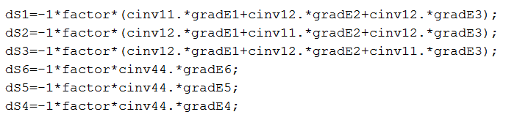

Figure 3.19 Part of the code showing the use of a ‘factor’

The Newton-Raphson method is a method that involves the gradient of a function, and may lead to oscillation depending on the function and its gradient. Therefore, a ‘factor’ of less than unity is introduced in the step that calculates the $∆ε$, so that oscillation is reduced and the graph will be smoother. Figure 3.15 shows a part of the code that involves this factor. Note that dS1- dS6 represents the six $∆ε_{ij}$ components.

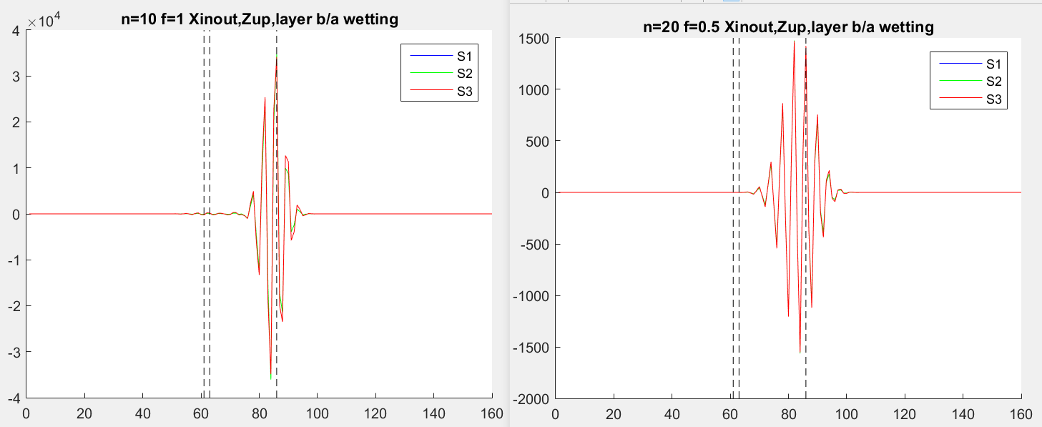

Figure 3.20 Plot of normal strain for factor, f=1 (left) and f=0.5 (right)

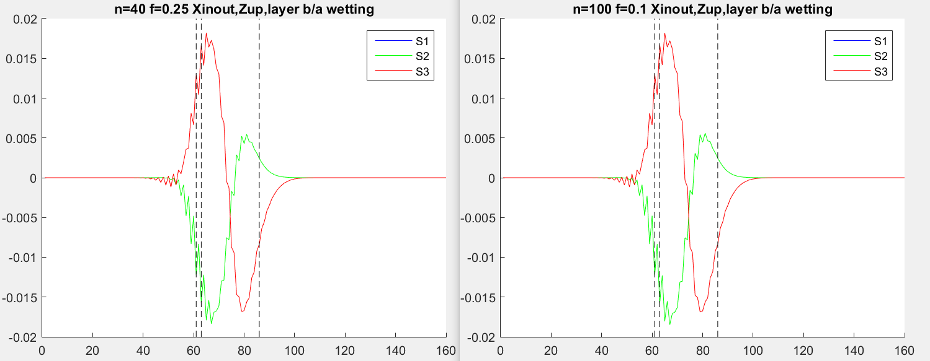

Figure 3.21 Plot of normal strain for factor, f=0.25 (left) and f=0.1 (right)

Figure 3.20-3.21 shows the importance of including this factor, where in each case the product of the number of steps, n and the factor, f, is a constant 10. When f=1, which represents the case where the factor is not included, the calculated change in strain resulted in a reduction in the displacement such that further strain calculation tends to zero in the wetting layer and bottom half of the pyramid, while dramatic oscillations happened towards the top. Reducing the factor to 0.5 changed a similar situation. However, when the factor is further reduced to 0.25, we were able to obtain a plot similar to our results obtained in the earlier subchapters. In fact, further reducing the factor to 0.1 did not result in much difference nor smoothening of the graph, contrary to what we expect. Figure 3.21 shows this comparison and it seemed that further reducing the factor does not benefit us by giving better results while costing twice the number of computation steps hence time. A factor of 0.01 was used to obtain all the previous plots prior to this subchapter and again yielded similar results. We conclude that a factor of about 0.1 is the limit of improving the accuracy while not wasting computational time. Thus, a different approach is required to further improve the accuracy and smoothening the plots, such as by further reducing the step size. This can be done selectively only on the areas close to the dot to not waste computational time.

# Piezoelectric charge and Potential

## Formulation

One might notice that the shear strain is not directly used as a benchmark throughout Chapter 3, even though it was used in part of the calculation in determining the simple strain. However, the shear strain directly leads to a polarization vector that cause charge to be accumulated, as given by

(4.2)

(4.1)

$$ρ=-∇∙P$$

$$ρ=-∇∙e_{14}\left(\begin{matrix}ε_{yz} \\ ε_{xz} \\ ε_{xy}\end{matrix}\right)$$

where $e_{14}$ is the piezoelectric constant of the material. This means that a dipole moment or an electric potential is present within the quantum dot. The Poisson equation, relates this induced charge density to the resultant piezoelectric potential

(4.3)

$$ε_{0}∇∙\left(ε_{r}∇V\right)=ρ=-∇∙P$$

Where $ε_{0}$ is the permittivity of free air and ${ ε}_{r}$, the dielectric constant of the material is a constant in this case.

Table 4.1 Piezoelectric properties of materials

|  |  |  |
| --- | --- | --- |
| Properties | GaAs | InAs |
| Lattice constant, (Cm­-2) | -0.16 | -0.045 |
| $$Dielectric constant{, ε}_{r} (static)$$ | 12.9 | 15.15 |

Hence, we can rearrange equation 4.3 and set the function to zero, attempting to again use Newton Raphson’s method to solve it.

(4.6)

(4.5)

(4.4)

$$f\left(r\right)=ε_{0}∇∙\left(ε_{r}∇V(r)\right)-ρ$$

$$f\left(r\right)=ε_{0}ε_{r}∇^{2}V(r)-ρ=0$$

$$f(r)=ε_{0}ε_{r}\left(\frac{d^{2}}{dx^{2}}V(r)+\frac{d^{2}}{dy^{2}}V(r)+\frac{d^{2}}{dz^{2}}V(r)\right)-ρ=0$$

Here, we can use finite difference[15] to approximate the second order differentials in the Laplacian from the values of 2 neighboring points, an example in x is given in Eqn 4.7. This causes the function to become a function of V itself instead of the spatial coordinates, $r=(x,y,z)$.

(4.8)

(4.7)

$$\frac{d^{2}}{dx^{2}}V=\frac{V^{x+1}-2V+V^{x-1}}{{∆x}^{2}}+O({∆x}^{2})$$

$$f\left(x,y,z\right)=0→f\left(V\right)=0$$

Next, the charge density can also be determined by the finite difference method

(4.11)

(4.10)

(4.9)

$$∇∙\left(\begin{matrix}ε_{yz} \\ ε_{xz} \\ ε_{xy}\end{matrix}\right)=\frac{∂}{∂x}\left(ε_{yz}\right)+\frac{∂}{∂y}\left(ε_{xz}\right)+\frac{∂}{∂z}\left(ε_{xy}\right)$$

$$\frac{∂}{∂x}\left(ε_{yz}\right)=\frac{ε_{yz}\left(x+1,y,z\right)-ε_{yz}\left(x-1,y,z\right)}{2∆x}$$

$$∆V=-\frac{f(V_{0})}{f^{'}(V_{0})}$$

Eqn 4.11 shows the newton iteration step. The function value in the numerator can be calculated directly from Eqns 4.6-4.7. The first differential in the denominator is then given by

(4.12)

$$\frac{∂}{∂V}f\left(V\right)=ε_{0}ε_{r}×\left(\frac{-2}{{∆x}^{2}}+\frac{-2}{{∆y}^{2}}+\frac{-2}{{∆z}^{2}}\right)$$

## Results

The algorithm is applied on the results from the previous chapter. Surface plots of the potential in the quantum dot are obtained.

### Shear strain

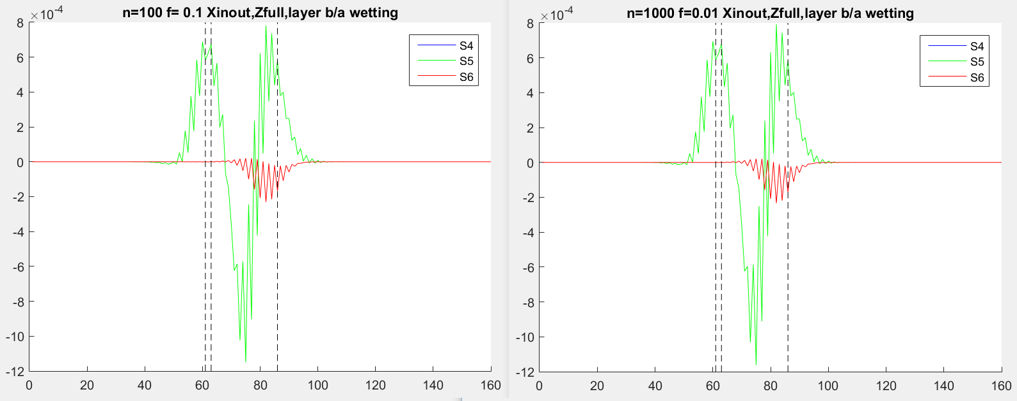

Figure 4.1 Shear strain along line scan A for f=0.1 (left) and f=0.01 (right)

Figure 4.1 shows the plot of the shear strains in the pyramidal dot. Previously, we have shown in chapter 3.4.5 that a factor or 0.1 and 0.01 produced similar results for the simple strain. Here, we first check that it also produces similar results for the shear strains. This is indeed true as shown in Figure 4.1. Note that $ε_{yz}$ and $ε_{xz}$ are identical and are stacked in the figure (S4 and S5).

From the plot, we observe that $ε_{yz}$ changes sign a few times in the simulation domain. It hits a maximum in the wetting layer and decreases rapidly to a minimum at about half the height of the dot. It then increases again and hit a maximum near the top of the dot. Since the line scan is along the Z-axis, the sign of the value basically tells us the direction of the shear at increasing height of the pyramid, negative being inwards while positive being outwards.

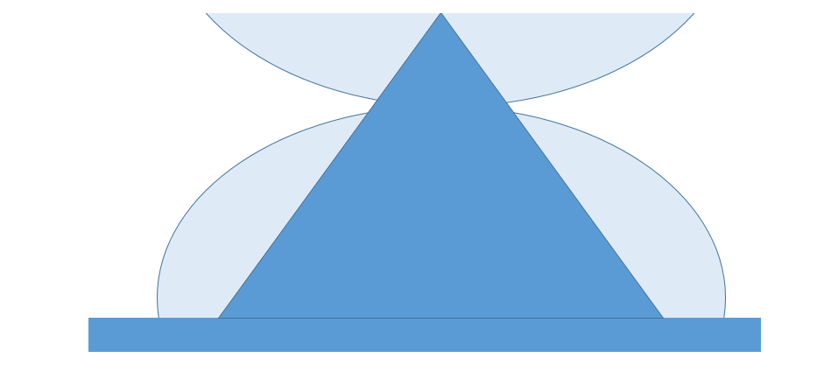

Figure 4.2 Visualization of change in shape due to induced shear strain

This result obtained is significant as it can be visualized as the full pyramid being distorted into a dome with the neck somewhere before the top of the pyramid, as shown in Figure 4.2. This gives us clues that the grown quantum dots are commonly in a truncated pyramidal or a dome shape, as shown in Figure 1.1-1.3, due to the shear strain favouring a truncation before reaching the full height of the pramid. Thus, the simulation domain in Chapter 5 for a pair of stacked dots uses truncated pyramids instead of a full one. The effect of $ε_{xy}$ is less significant in comparison, and only appears near the top of the pyramid. This has minimal impact on the shape of the quantum dot.

### Surface plots

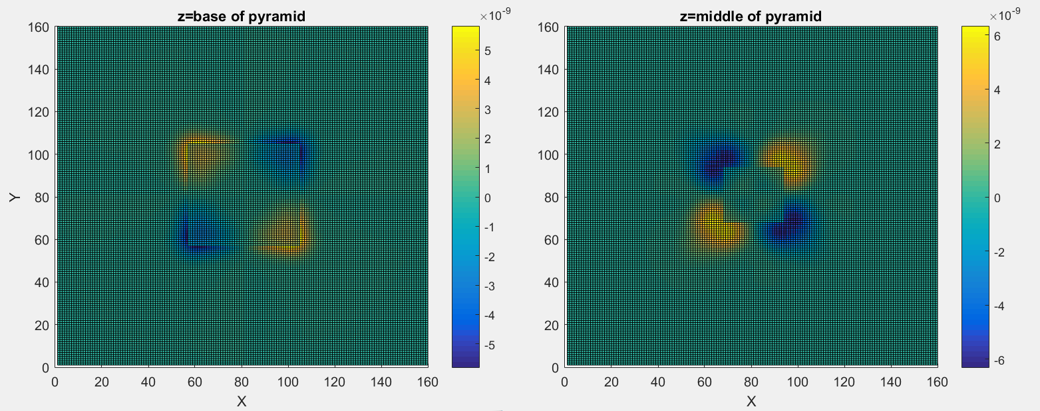

Figure .3 Surface plot (X-Y plane) of potential at Z=base of pyramid (left) and Z=middle of pyramid (right)

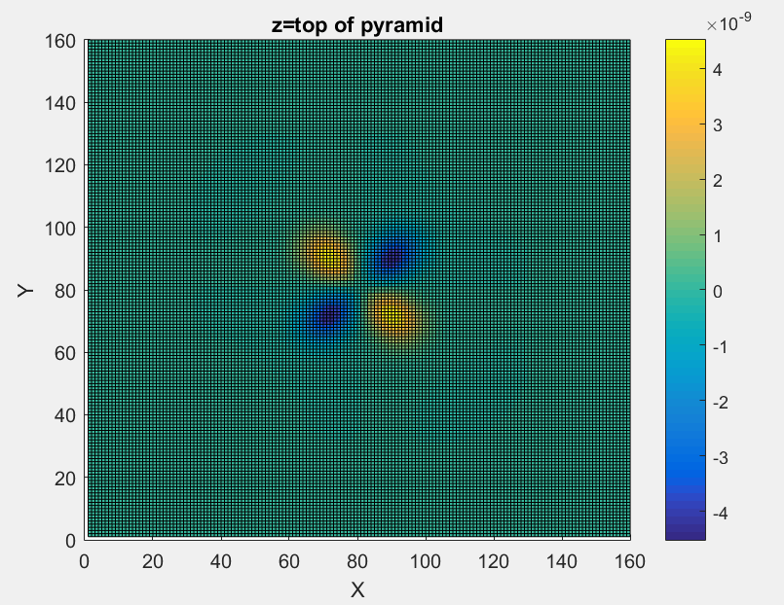

Figure 4.4 Surface plot (X-Y plane) of potential at Z=top of pyramid

Figure 4.3-4.4 shows a 2D surface plot of the x-y plane at different height. There are several observations that we can make here

1. At each height, the potential is concentrated at the 4 corners of the pyramid.
2. The sign alternates at each corners of the pyramid.
3. At half the height, the potential at each corner changes sign. In other words, the corners which were positive at the base of the pyramid became negative. This is reverted again at the top of the pyramid.
4. At increasing height, the potential becomes more dispersed and the shape tends to an ellipse.

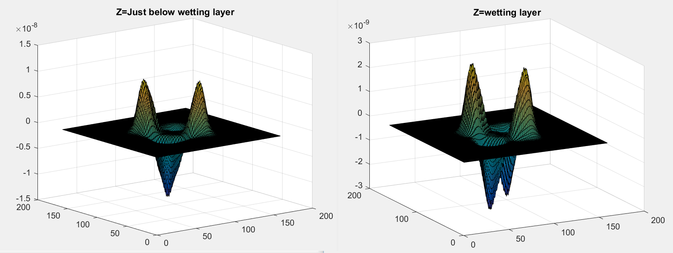

Figure 4.5 Surface plot (X-Y plane) near wetting layer

Figure 4.5 shows that this result extends beyond the wetting layer and diminishes into the substrate layers.

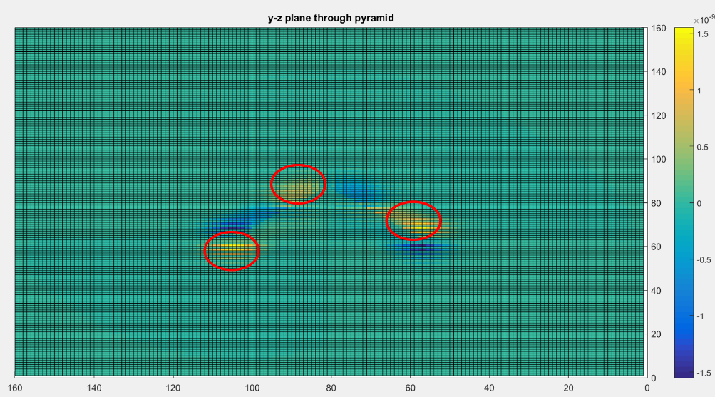

Figure 4.6 Surface plot 1 (Y-Z plane) of potential through the middle of the pyramid

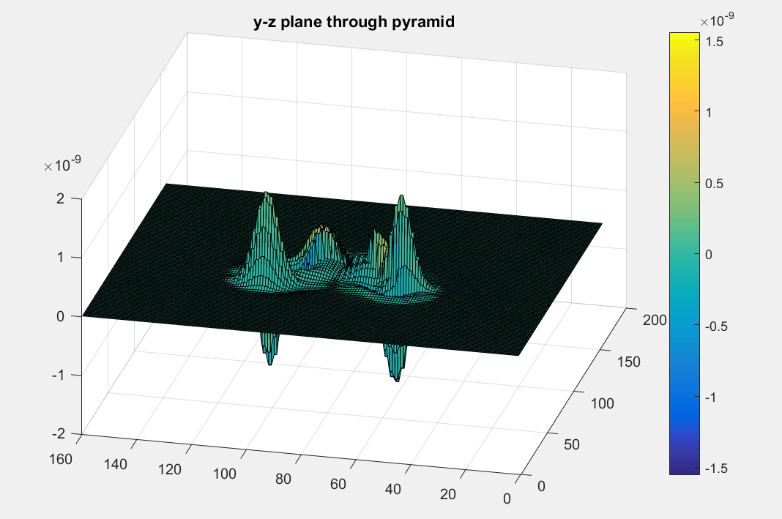

Figure 4.7 Surface plot 2 (Y-Z plane) of potential through the middle of the pyramid

Figure 4.6-4.7 shows the surface plot along the plane Y-Z. It agrees with point 3 made above which shows that the sign of the potential flips twice within the pyramid, as highlighted by the red circles. It also shows that the magnitude falls with height and that the potential extend about 1-2nm into the surround substrate and capping layer.

## Conclusion

The simulation shows that there is a significant strain-induced piezoelectric potential field within the quantum dot, and its effect extends into the surrounding substrate even though it is largely confined within the dot. There are regions within the dot that have zero potential while the others have alternating signs with increasing height. Hence we expect the potential to have a significant role in the calculation of the band structure via the Schrodinger equation.

# Stacked Quantum Dots

## Simulation domain

In this chapter, we apply similar analysis to the strain and potential field in a stacked quantum dot, also known as a quantum molecule. Figure 5.1 shows the simulation domain where the InAs material is marked in yellow. The distance, d is varied from 2 to 6nm.

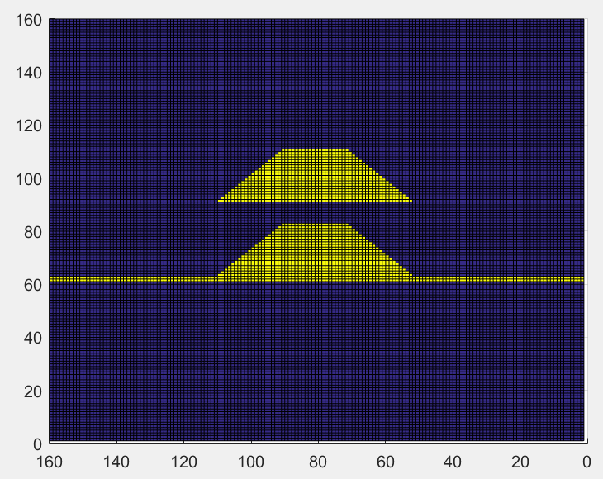

Height =6nm

Base = 12nm

Upper width = 6nm

Distance, d

Figure 5.1 Simulation domain for stacked quantum dots

## Distance 2nm

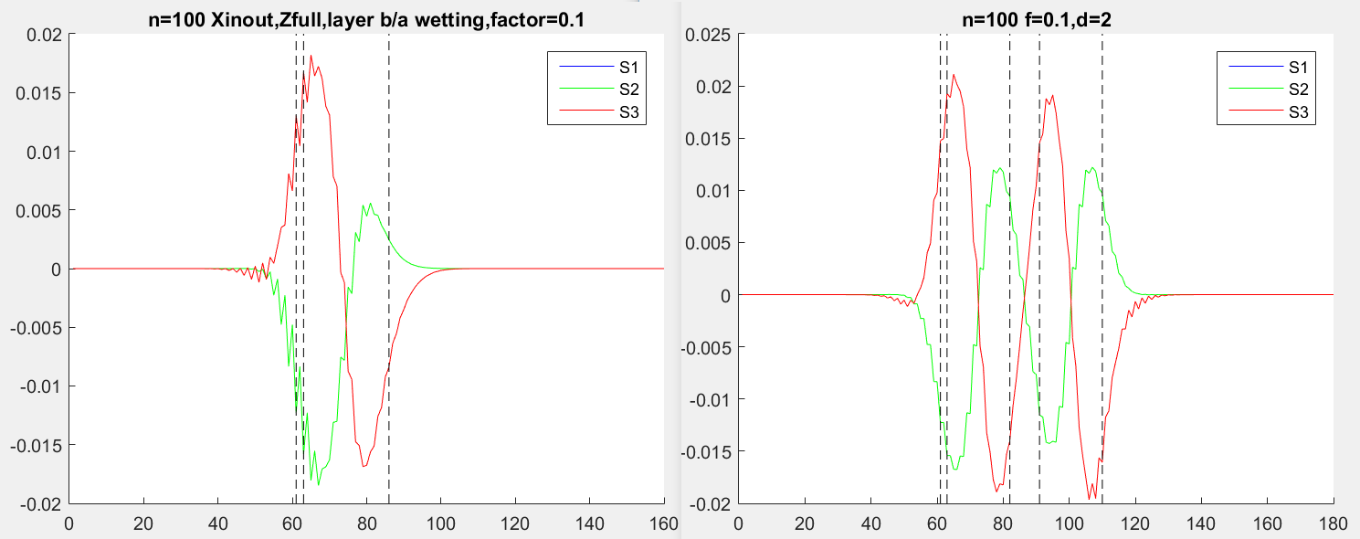

Figure 5.2 Strain profile for stacked dots, d=2 (right) compared with a single dot (left)

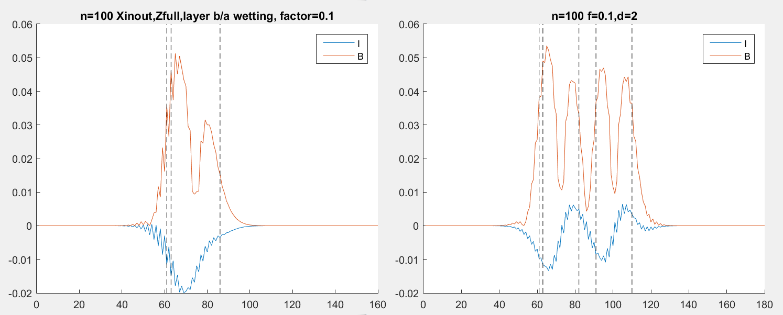

Figure 5.3 Isotropic and biaxial strain for stacked dots, d=2 (right) compared with a single dot (left)

Figure 5.2-5.3 shows the results from applying the algorithm obtained in chapter 3 to a simulation domain of a quantum dot molecule, where the separation distance, d, is 2nm. The previous results obtained for a single dot is shown again for comparison. We analyse the observations made.

1. With reference to Figure 5.2, the simple strain joins smoothly between the 2 dots. It can be noted that close to the top of both dots, the in plane strain becomes more positive, while the strain in z becomes more negative. This shows the influence of the dot on each other as well as the influence from the wetting layer.
2. For a single dot, the biaxial strain has 2 peaks at the base and near the top of the pyramid while having a distinct minimum in the dot (Figure 5.3). For the quantum dot molecule, this strain near the top of the pyramid in amplified and another distinct minimum is observed in between the dots. This leads to a region free of piezoelectricity.
3. The isotropic strain as shown in Figure 5.3 is entirely negative within the single dot. As the isotropic strain represents a change in volume, the quantum dot experiences a decrease in volume, and we can understand this as a compression from all sides by the GaAs material. However, in the quantum dot molecule, the isotropic strain becomes positive at the lower dot. Since this also happens to the top dot, it could either be a coupling effect or simply because of the change in shape of the pyramid. In general, we observe that the upper dot experiences a smaller isotropic compression, hence might have a slightly larger volume. This was indeed confirmed by J. P. McCaffrey et al. (2000) [18].

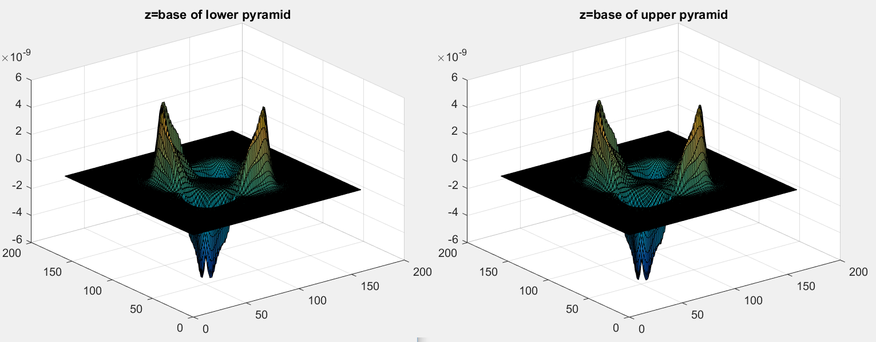

Figure 5.4 X-Y Surface plot of potential at Z=base of lower pyramid (left) and Z=base of upper pyramid (right)

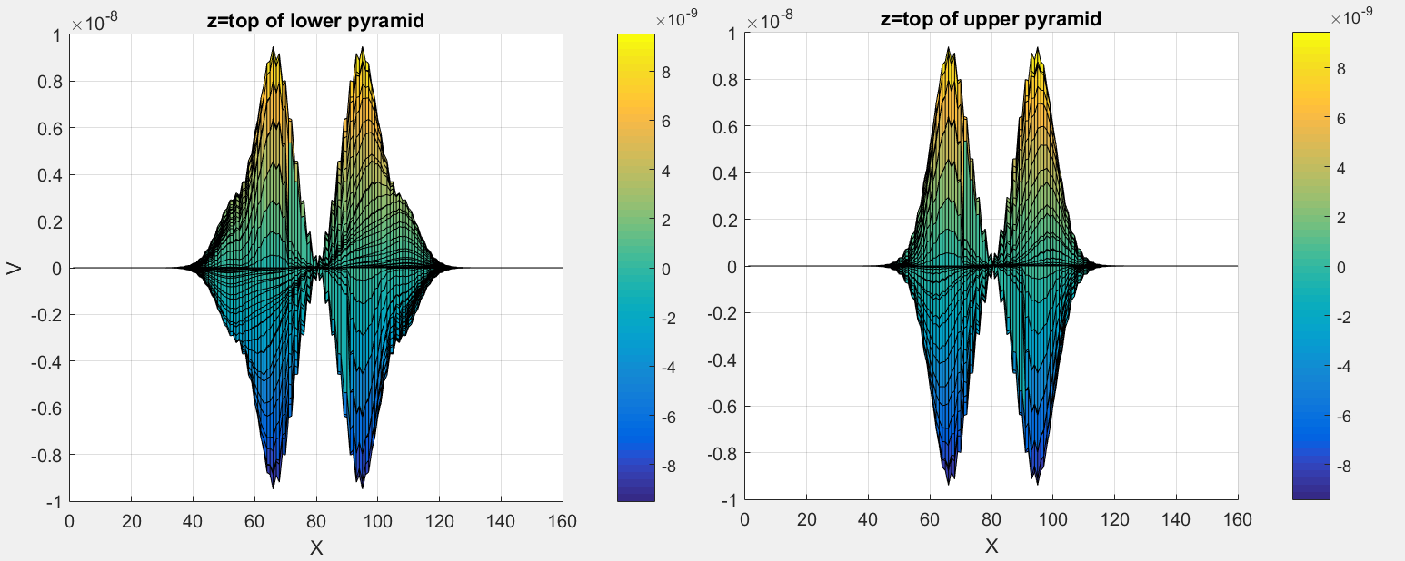

Figure 5.5 X-Y Surface plot of potential at Z=top of lower pyramid (left) and Z=top of upper pyramid (right)

We apply the algorithm developed in Chapter 4 to calculate the potential induced in a quantum dot molecule. Figure 5.4 shows that there is not much difference between the potential at the base of the lower and upper dot. They are also similar to the plot for a single dot case. Figure 5.5 shows the surface plot at the top of each quantum dot. We can observe a difference between these plots. The potential at the top of the lower dot has a wider profile over X and Y, showing the influence that the top dot has over its induced potential.

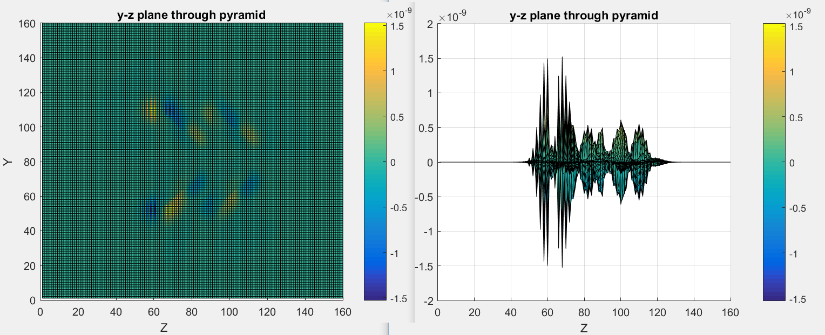

Figure 5.6 Y-Z Surface plot of potential at through the middle of the pyramid

Figure 5.6 is a Y-Z surface plot through the middle of the pyramids. We observe a similar pattern of alternating signs within each quantum dots, just like in the single dot case. The magnitude is similar in both dots, except for at the base of the lower pyramid, likely due to the presence of the wetting layer.

## Distance 4nm

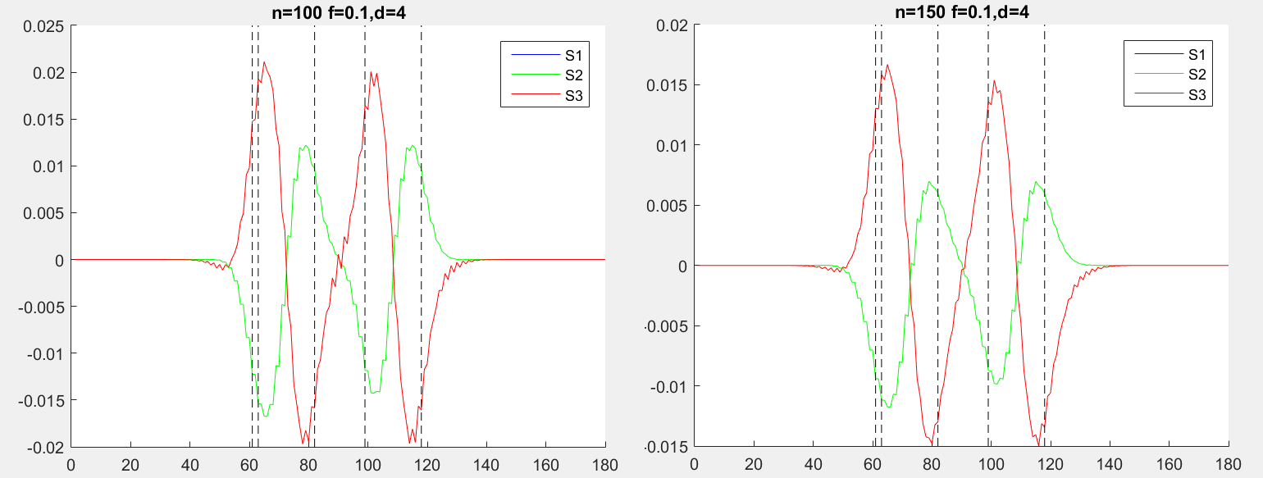

Figure 5.7 Strain profile for stacked dots, d=4, n=100 (left) compared with n=150 (right)

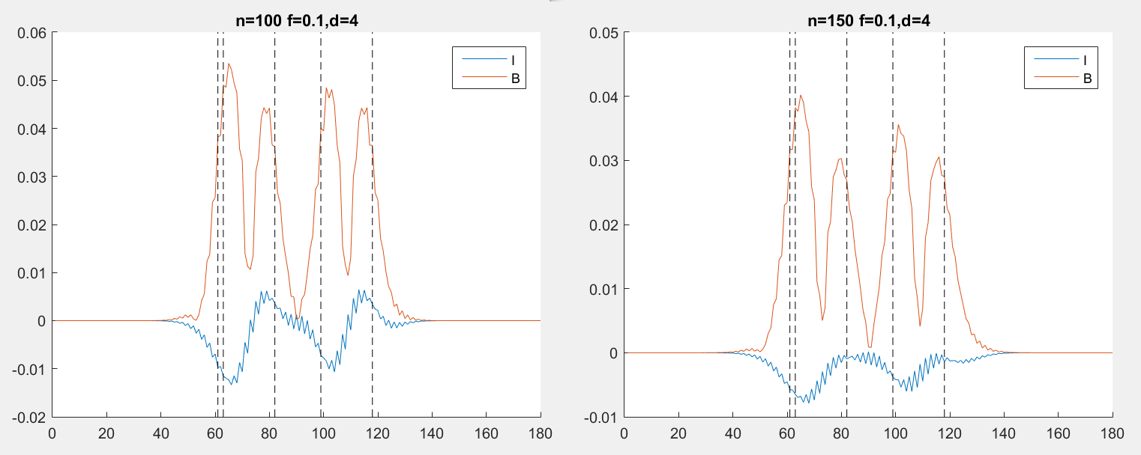

Figure 5.8 Isotropic and biaxial strain for stacked dots, d=4, n=100 (left) compared with n=150 (right)

Similar observations for strain was obtained for a separation distance of 4nm. However, increasing the number of steps in our simulation shows that the isotropic strain is indeed entirely negative within the dot. This shows that the results in Chapter 5.2 likely also shows that both the quantum dots experiences a decrease in volume.

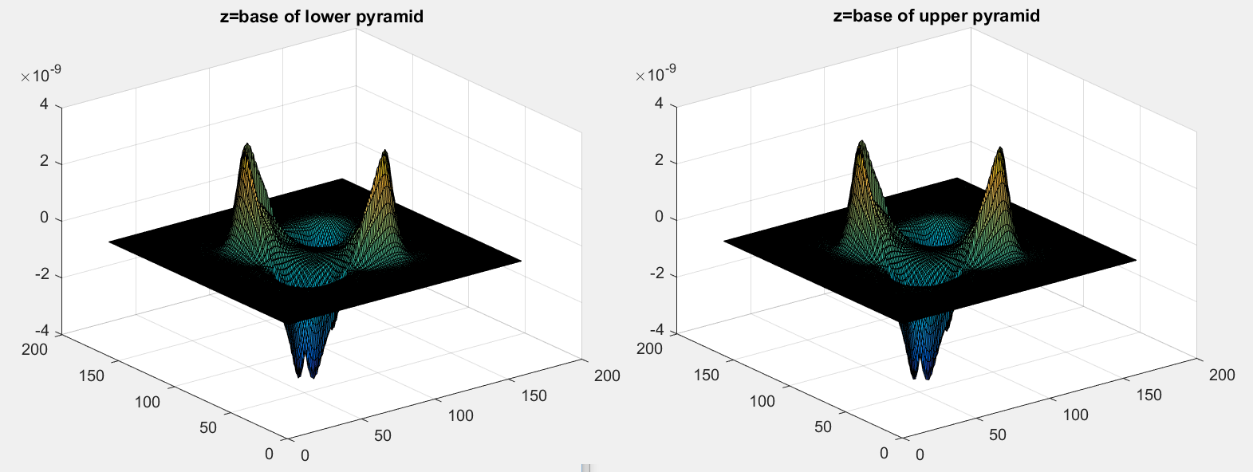

Figure 5.9 X-Y Surface plot of potential at Z=base of lower pyramid (left) and Z=base of upper pyramid (right), d=4nm

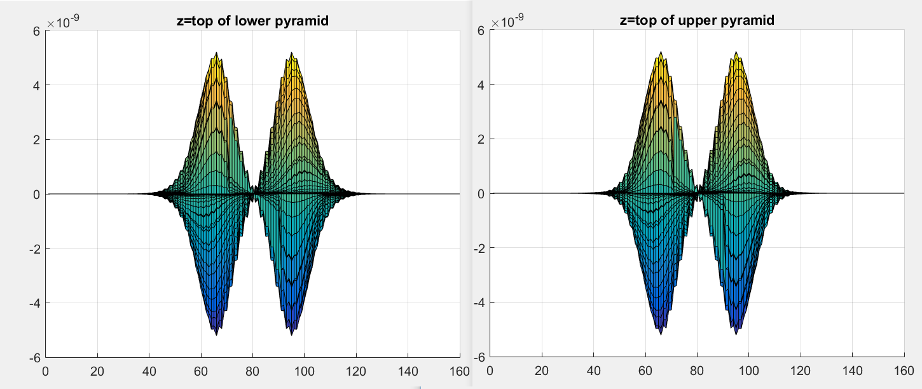

Figure 5.10 X-Y Surface plot of potential at Z=top of lower pyramid (left) and Z=top of upper pyramid (right), d=4nm

Results similar to the 2nm case were obtained for the potential simulation. The only difference is that the increased width in Figure 5.5 is no longer observed in Figure 5.10. This observation shows that with an increase in the separation distance, it is likely that the coupling effect between the dots is starting to disappear.

## Distance 10nm

Further increasing the distance to 10nm, similar plots for strain in observed. The strain in each quantum dot are independent with respect to each other, and there is an area of zero strain between the quantum dots.

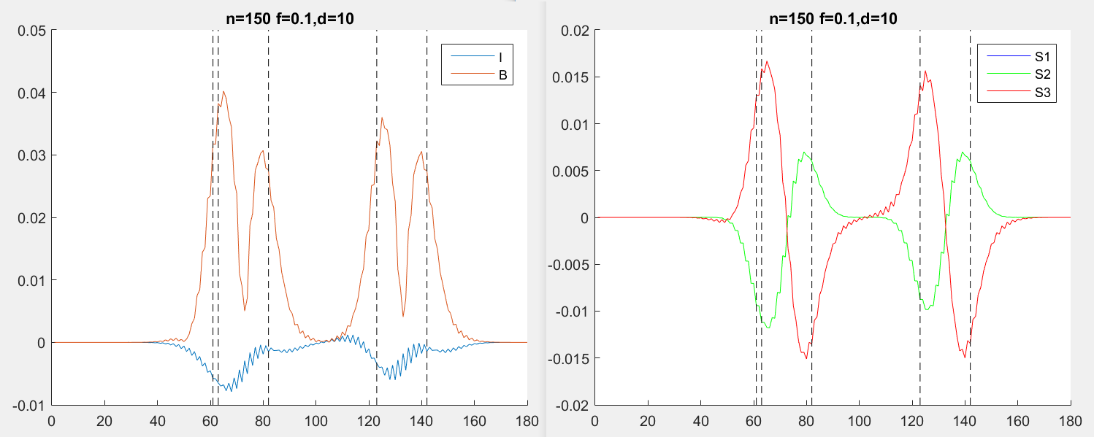

Figure 5.11 Isotropic and biaxial strains (left) and normal strains (right) in a quantum dot molecule with d=10nm

Plots of potential at the base of each dot are similar to each other and to the previous results, and are not shown here. It can be concluded that the large separation distance has led to complete decoupling between the dots.

## Conclusion

From the results of a single dot we have seen that the strain profile extends into the material surrounding the dot. We have observed in this chapter that this strain field results in a coupling effect within a quantum dot molecules, leading to modified strain and potential profile. This coupling effect is distance dependent as expected, and decreases with increasing distance. The developed algorithm has showed that it can potentially be used to investigate this coupling effect with respect to distance. With further improved accuracy, the algorithm would be able to determine the maximum distance before the coupling effect diminishes. This is extremely useful in the growth of quantum dot molecules and for studies that involves such molecules.

# Electronic Structure

## nextnano

In the interest of time, we turned to a commercial software called nextnano [12] to get an idea of the simulation of the electronic structure. Nextnano is a nano device simulator software developed by CEO Stefan Birner, who has provided me with a 1-month license as a free trial of the product.

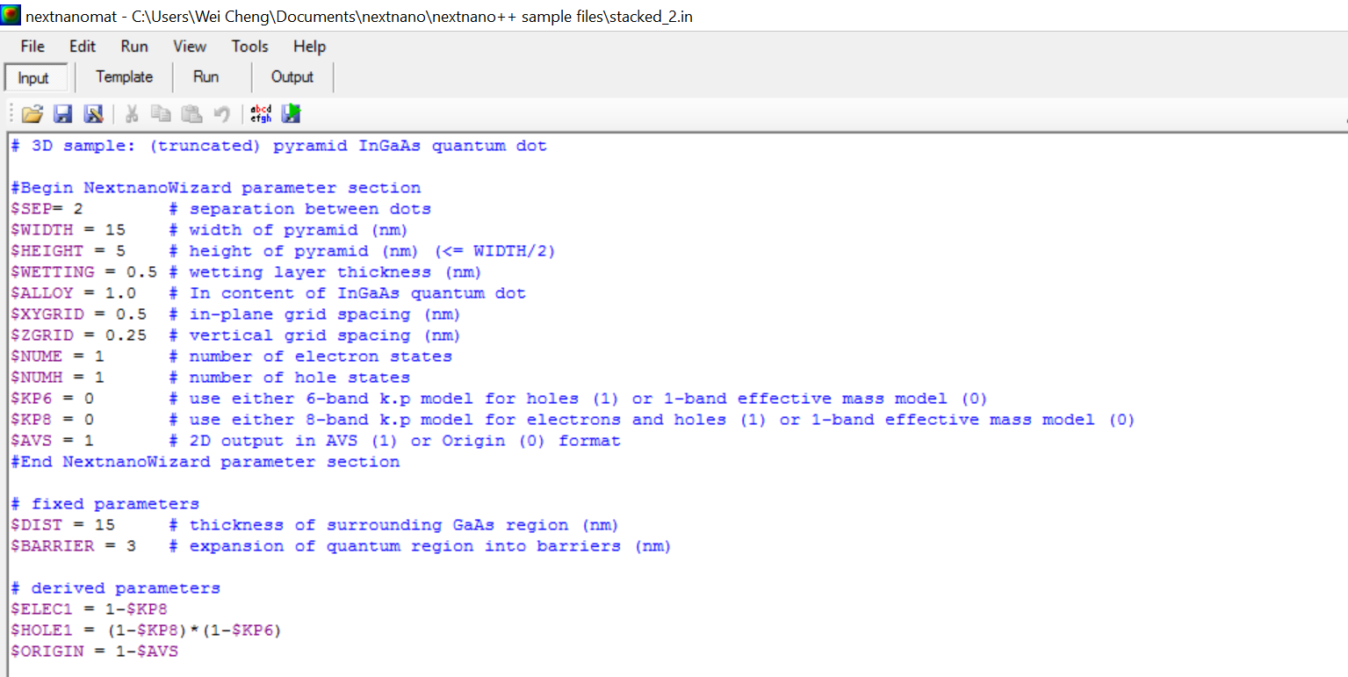

Figure 6.1 Command window of nextnano

Nextnano resembles MATLAB as a text base program for simulation. After learning its syntax, the program can be used for simulation in a similar fashion. However, as it is specific for the simulation of nano devices, it is more efficient and convenient to use. For example, the user can specify varying step size at different areas of the simulation, which would otherwise be tedious in MATLAB. The material parameters are preloaded hence only the material has to be specified. Towards the end of the project, time was taken to learn and understand the syntax of the program, so that the input can be modified to fit our simulation domain.

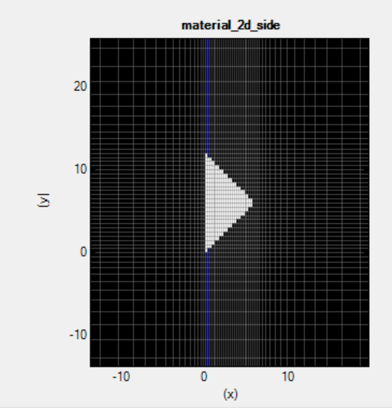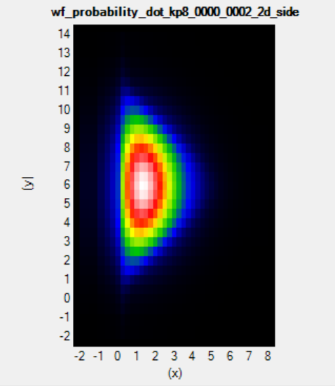

Figure 6.2 Examples of output from nextnano

## Single Quantum dot

We first use nextnano to reproduce and check our results from the previous chapters.

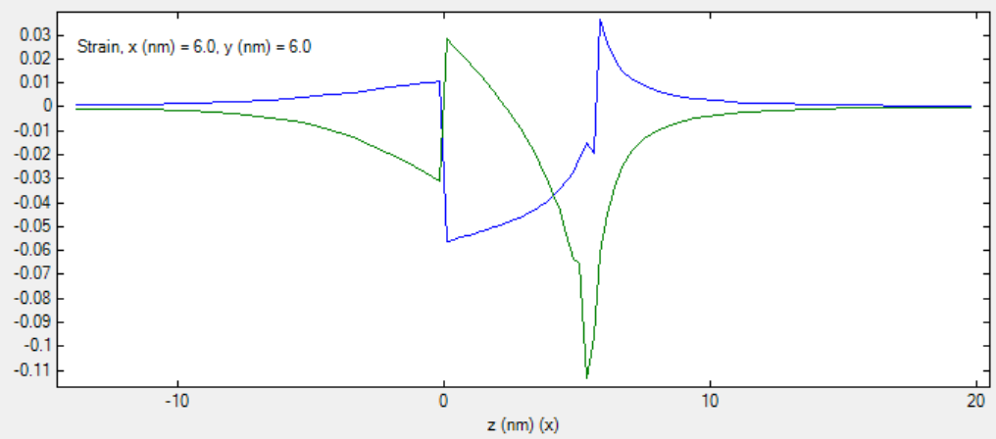

Figure 6.3 Normal strain in single dot along line A.

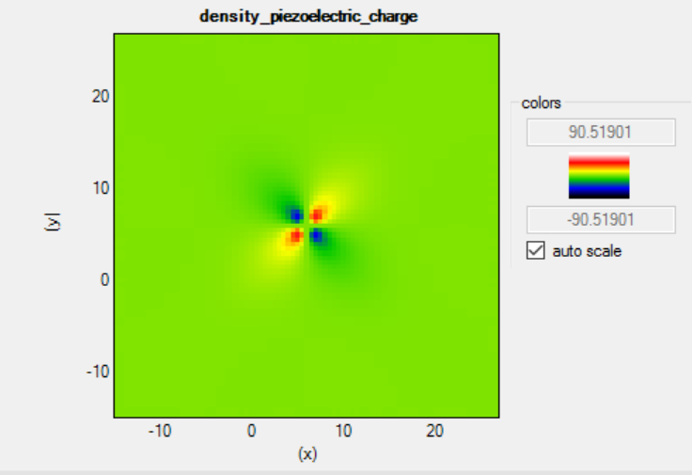

Figure 6.4 Charge density at bas of pyramid

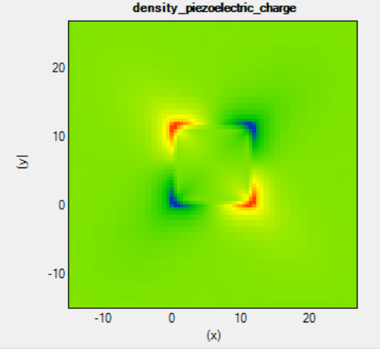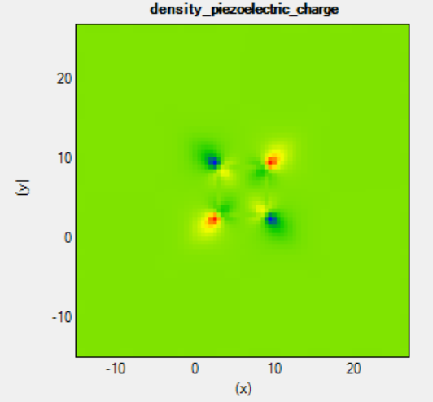

Figure 6.5 Charge density at base of pyramid (left) and at half height (right)

The results for strain are consistent with Figure 3.2. On top of that, the shape of the results for charge density agrees with that of our simulation.

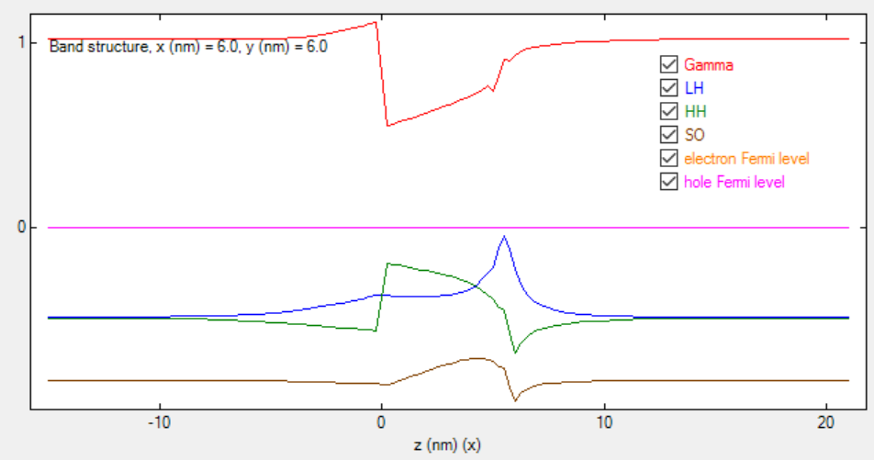

Figure 6.6 Bandedges along line A

Figure 6.4 shows the calculated band edges. We notice that the light hole (LH) and heavy hole (HH) band edges crosses each other and each of them is nearer to the fermi level at different heights of the dot. The split off (SO) hole band edge lies below them.

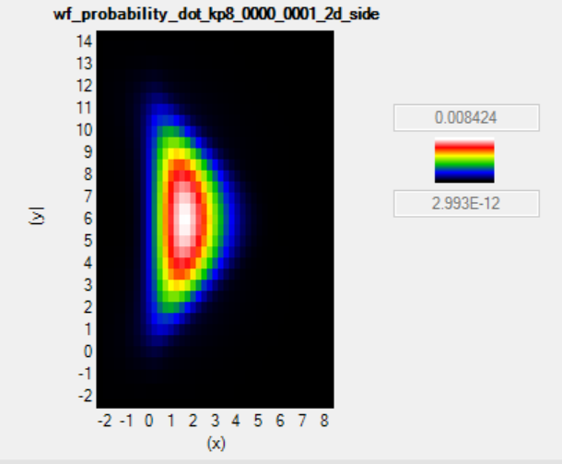

Figure 6.7 Probability density of electron ground state

## Stacked Quantum dot

An input file is edited such that the simulation domain is as shown in Figure 6.8, where the separation, d=2nm.

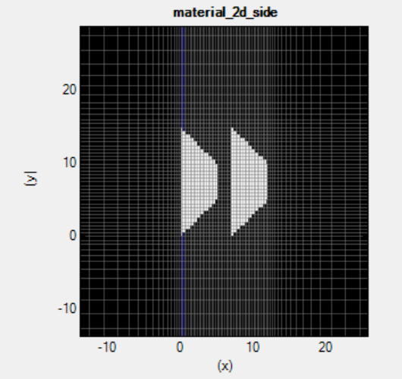

Figure 6.8 Simulation domain with gridlines. d=2nm

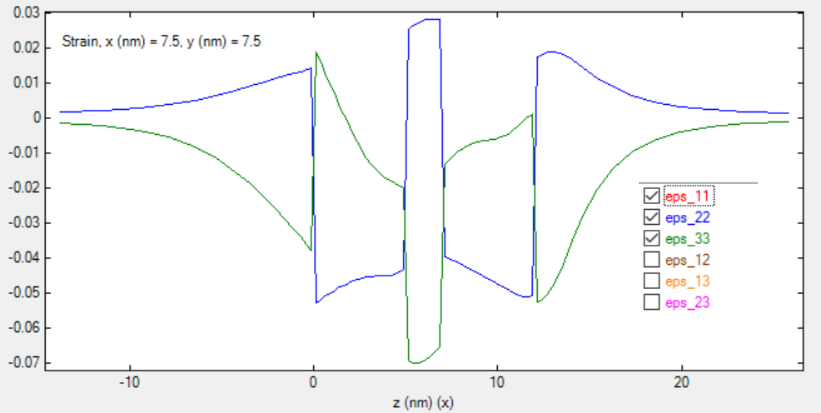

Figure 6.9 Strain profile along line A

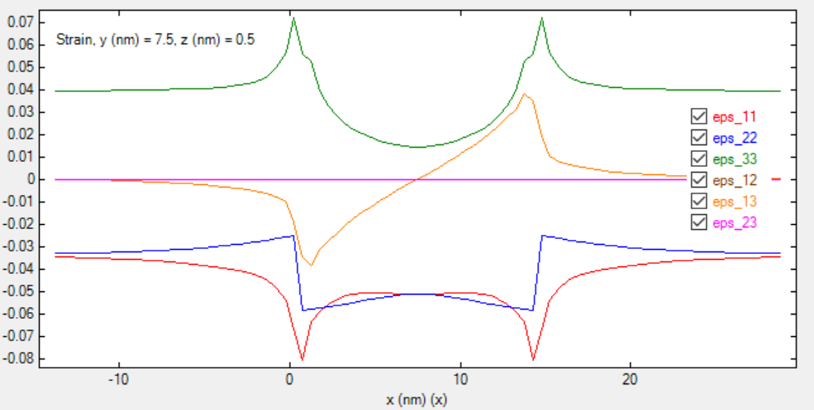

Figure 6.10 Strain profile in the x direction along base of pyramid

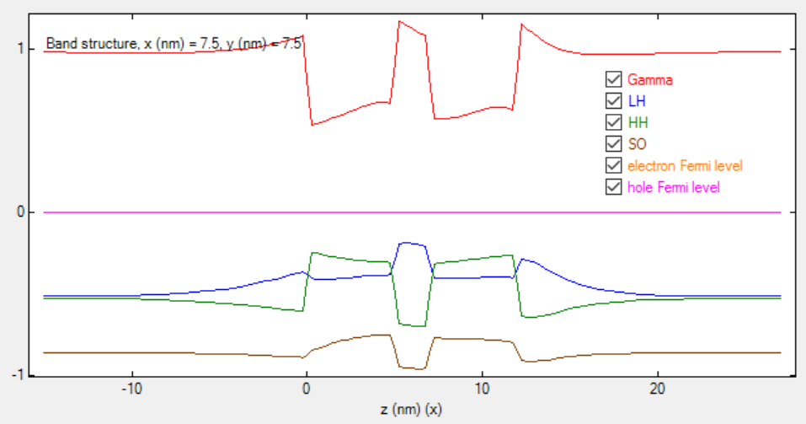

Figure 6.11 Band edges along line A

Figure 6.9 shows the strain profile along line A. The results show that there is a large change in strain at the boundaries of the dots. In particular, the slab of GaAs in between the 2 dots is heavily compressed (negative ${ ε}_{zz}$) while being pushed outwards in the X-Y plane (positive $ε_{xx}$). The strain at the base of the upper dot is also significantly different from the strain at base of the lower dot. It is also noted that the shear strain calculated by the program is a constant zero for all cases. However, the shear strain along the x axis is non-zero, as shown by Figure 6.10. This implies that the algorithm used is different from the one that was developed using MATLAB, and possibly a mistake in that algorithm.

It is observed from Figure 6.11 that within the 2 quantum dots, the heavy hole band edge is consistently above that of the light hole, a result that differed from the single dot case.

The simulated probability density is shown below. It can be seen that the electron state is confined within the bottom dot, while that of the hole has a probability to exist in the upper dot.

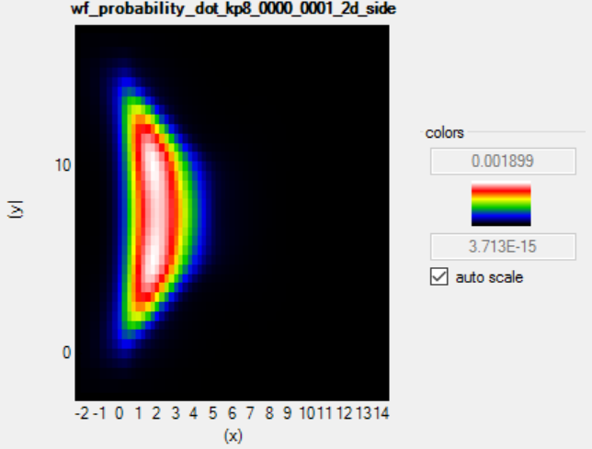

Figure 6.12 Electron probability density surface plot

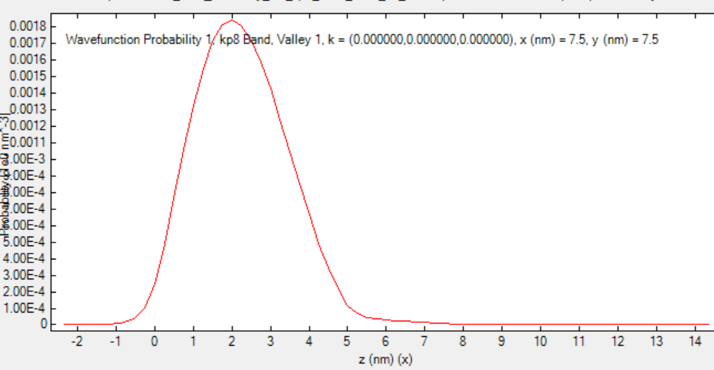

Figure 6.13 Electron probability density along line A

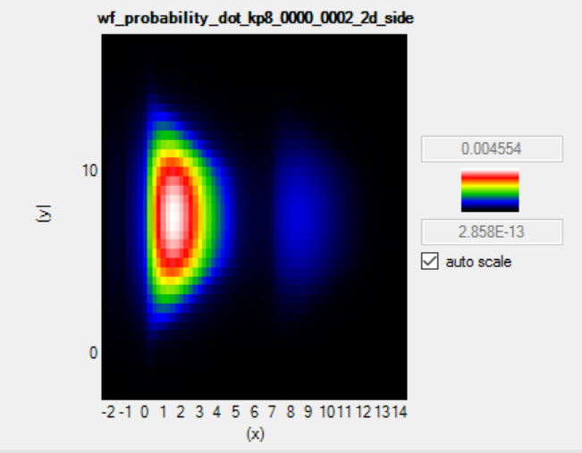

Figure 6.14 Hole probability density surface plot

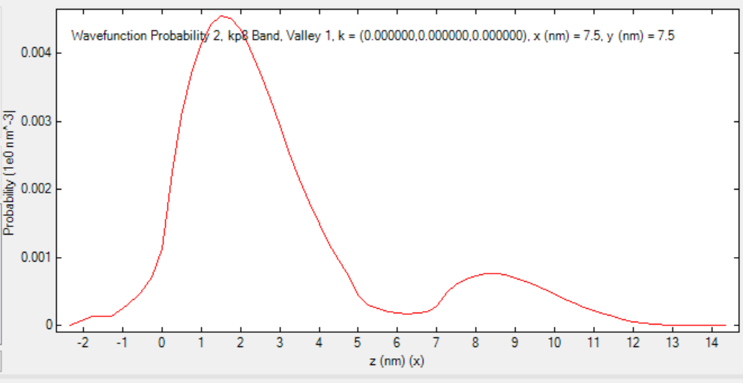

Figure 6.15 Hole probability density along line A

# Conclusion

From the simulation results, it can be seen that the electronic property of a quantum dot molecule is heavily influenced by the induced strain field, when there is a lattice mismatch between materials. The strain leads to an induced piezoelectric potential and also affects the electronic structure of the quantum dot molecule.

The ideal progression of the project was to develop a rigid code in MATLAB that would then allow for simulations in the presence of electric and magnetic field, and analyse their effects. For example, Muhammad Usman (2011) [1] explains that an applied electric field can control the coupling between such stacked quantum dots, switching an exciton between the indirect and direct state. H. J. Krenner et al. [11] has also demonstrated such controlled coupling using a static electric field. While nextnano does not support the addition of such fields, it gave an idea of the electronic structure of the stacked quantum dots and its properties.

As this project is computational based, heavy focus was placed on the formulation and coding of the strain and potential calculation. The project has exposed me to a very specialized field of research and have taught me valuable lessons in the process of developing the code and analysing the results. The main learning points are in computational methods and modelling, which has proved to be a difficult but essential part of research.

References

1. Muhammad Usman, "Excited State Spectroscopy of a Quantum Dot Molecule", Purdue University
2. M. Usman, Y. Tan, H. Ryu, S. Ahmed, H. Krenner, T. Boykin and G. Klimeck, "Quantitative excited state spectroscopy of a single InGaAs quantum dot molecule through multi-million-atom electronic structure calculations", *Nanotechnology*, vol. 22, no. 31, p. 315709, 2011.
3. M. Thompson, A. Rae, Mo Xia, R. Penty and I. White, "InGaAs Quantum-Dot Mode-Locked Laser Diodes", *IEEE J. Select. Topics Quantum Electron.*, vol. 15, no. 3, pp. 661-672, 2009..
4. H. Liu, T. Wang, Q. Jiang, R. Hogg, F. Tutu, F. Pozzi and A. Seeds, "Long-wavelength InAs/GaAs quantum-dot laser diode monolithically grown on Ge substrate", *Nature Photonics*, vol. 5, no. 7, pp. 416-419, 2011.
5. M. Grundmann, O. Stier and D. Bimberg, "InAs/GaAs pyramidal quantum dots: Strain distribution, optical phonons, and electronic structure", *Phys. Rev. B*, vol. 52, no. 16, pp. 11969-11981, 1995.
6. W. Sheng and J. Leburton, "Anomalous Quantum-Confined Stark Effects in Stacked InAs / GaAs Self-Assembled Quantum Dots", *Phys. Rev. Lett.*, vol. 88, no. 16, 2002.
7. H. Krenner, M. Sabathil, E. Clark, A. Kress, D. Schuh, M. Bichler, G. Abstreiter and J. Finley, "Direct Observation of Controlled Coupling in an Individual Quantum Dot Molecule", Phys. Rev. Lett., vol. 94, no. 5, 2005.
8. J. Villas-Bôas, A. Govorov and S. Ulloa, "Coherent control of tunneling in a quantum dot molecule", *Phys. Rev. B*, vol. 69, no. 12, 2004.
9. C. Pryor, J. Kim, L. Wang, A. Williamson and A. Zunger, "Comparison of two methods for describing the strain profiles in quantum dots", *J. Appl. Phys.*, vol. 83, no. 5, p. 2548, 1998.
10. L. Landau and E. Lifshit︠s︡, *Theory of elasticity*. London: Pergamon Press, 1959.
11. H. Krenner, M. Sabathil, E. Clark, A. Kress, D. Schuh, M. Bichler, G. Abstreiter and J. Finley, "Direct Observation of Controlled Coupling in an Individual Quantum Dot Molecule", Phys. Rev. Lett., vol. 94, no. 5, 2005.
12. "nextnano3 - next generation 3D nano device simulator", Nextnano.de, 2016. [Online]. Available: http://www.nextnano.de/nextnano3/index.htm. [Accessed: 17- Apr- 2016].
13. Y. Wang, W. Chen, B. Wang and Y. Zheng, "Ultrathin Ferroelectric Films: Growth, Characterization, Physics and Applications", *Materials*, vol. 7, no. 9, pp. 6377-6485, 2014.
14. "Growth of QDs", *Www2.warwick.ac.uk*, 2016. [Online]. Available: http://www2.warwick.ac.uk/fac/sci/physics/current/postgraduate/regs/mpags/ex5/lds/qd/growth/. [Accessed: 17- Apr- 2016].
15. "Fakultät - Fakultät für Mathematik, TU Dortmund", Mathematik.uni-dortmund.de, 2016. [Online]. Available: http://www.mathematik.uni-dortmund.de/. [Accessed: 17- Apr- 2016].
16. "NSM Archive - Physical Properties of Semiconductors", Ioffe.ru, 2016. [Online]. Available: http://www.ioffe.ru/SVA/NSM/Semicond/. [Accessed: 17- Apr- 2016].
17. T. Cheche and Y. Chang, "Analytical approach for strain and piezoelectric potential in conical self-assembled quantum dots", J. Appl. Phys., vol. 104, no. 8, p. 083524, 2008.
18. J. McCaffrey, M. Robertson, S. Fafard, Z. Wasilewski, E. Griswold and L. Madsen, "Determination of the size, shape, and composition of indium-flushed self-assembled quantum dots by transmission electron microscopy", J. Appl. Phys., vol. 88, no. 5, p. 2272, 2000.